**Project Report**

(submitted in partial fulfilment of the Degree of B.Sc. IT under the Assam Science and Technology University, Assam)

Title of the Project

**Online Food Ordering and Delivery System**

**Submitted by**

Name of the Candidate: **Pranay Kalita**

Registration No.**343308118**

Roll No. **180810033040**

Name of the College: **Jorhat Institute of Science and Technology**

Supervised by

Name of the supervisor: **Rajiv Kalita**

Month & Year of Submission

July,2021

Session 2018-19

**Supervisor's Certificate**

This is to certify that **Pranay Kalita** a student of B.Sc. IT of **Jorhat Institute of Science and Technology** under Assam Science and technology University, Assam has worked under my supervision and guidance for his project work and prepared a Project Report with the title **Online Food Ordering and Delivery System**, which he submitting, is his genuine and original work to the best of my knowledge.

Place: Jorhat Signature

Date:20/07/2021 Name: **Rajiv Kalita**

Designation:

************

# Supervisor's Certificate

This is to certify that **Pranay Kalita** a student of B.Sc. IT of **Jorhat Institute of Science and Technology** under Assam Science and technology University, Assam has worked under my supervision and guidance for his project work and prepared a Project Report with the title **Online Food Ordering and Delivery Syste**m, which he submitting, is his genuine and original work to the best of my knowledge.

Place: **Jorhat** Signature

Date:20/07/2021 Name: **Jameson Mushahary**

Designation:

************

**Student's Declaration**

I hereby declared that the project work with the title **Online Food Ordering and Delivery System** submitted by me for the partial fulfillment of B.Sc. IT under **Assam science and Technology university**, Assam is my original work and has not been submitted earlier to any other University/Institute for fulfillment of the requirements for any course of study. I also declared that no chapter of this manuscript in whole or part has been incorporated in this report from any earlier work done by others or by me. however, extracts of any literature which has being used for this report has been duly acknowledged providing details of such literature in reference.

Place: **Jorhat** Name**: Pranay Kalita**

Date:20/07/2021 Registration No: **343308118**

Roll No: **180810033040**

************

**ACKNOWLEDGEMENT**

I students of BSc.IT 6th semester of **Jorhat Institute of Science & Technology**, Jorhat undertake a project work on “**Online Food Ordering and Delivery System**” as our Major project for 6th semester under the guidance of **Mr. Rajiv Kalita.**

I greatly indebted to **Mr Jameson Mushahary, Mr. Hsuvas Borkakoty** and **Miss Himadri Neog** for their guidance and their encouragement.

At last but not the least we would like to extend our special thanks to all our friends whose cooperation and help during the project is ought to be noted without whom the project would be incomplete.

Thanking you all

**Pranay kalita**

B.Sc. IT 6th Semester

Jorhat Institute of Science & Technology, Jorhat

INDEX

Introduction 1

Objective of Project 2

Functionalities 2

Scope of The Project 3

Features 4

Modules 5

Tools and Technique 5

Requirement Analysis and Specification 9

Hardware Requirements 10

Software Requirements 10

Entity Relationship Diagram (ERD) 11

Data Flow Diagram(DFD) 12

Database 15

Database Relational Modal 16

Sitemap(Client) 17

Site map(Admin) 17

Front End Snapshots(Client) 18

Front End Snapshots(Admin) 24

Front End Snapshots(Delivery) 30

Plugins 32

Testing Technologies 35

Conclusion 36

Bibliography & Reference 37

# Introduction

The "**Online Food Ordering and Delivery System**(OFODS)" has been developed to override the problems prevailing in the practicing manual system. This software is supported to eliminate and in some cases reduce the hardships faced by this existing system. Moreover, this system is designed for the particular need of the company to carry out operations in a smooth and effective manner.

The application is reduced as much as possible to avoid errors while entering the data. It also provides error message while entering invalid data. No formal knowledge is needed for the user to use this system. Thus by this all it proves it is user-friendly. Online Food Ordering and Delivery System, as described above, can lead to error free, secure, reliable and fast management system. It can assist the user to concentrate on their other activities rather to concentrate on the record keeping. Thus it will help organization in better utilization of resources.

Every organization, whether big or small, has challenges to overcome and managing the information of Category, Food Item, Order, Payment, Confirm Order. Every Online Food Ordering and Delivery System has different Food Item needs, therefore, we design exclusive employee management systems that are adapted to your managerial requirements.

This is designed to assist in strategic planning, and will help you ensure that your organization is equipped with the right level of information and details for your future goals.

# Objective of Project

The main objective of the Project on Online Food Ordering and Delivery System is to manage the details of Food Item, Category, Customer, Order, Confirm Order. It manages all the information about Food Item, Payment, Confirm Order, Food Item. The project is totally built at administrative end and thus only the administrator is guaranteed the access. The purpose of the project is to build an application program to reduce the manual work for managing the Food Item, Category, Payment, Customer. It tracks all the details about the Customer, Order, Confirm Order.

# Functionalities

* Provides the searching facilities based on various factors. Such as Food Item, Customer, Order, Confirm Order
* Online Food Ordering and delivery System also manage the Payment details online for Order details, Confirm Order details, Food Item.
* Manage the information of Category
* Shows the information and description of the Food Item, Customer
* Manage the information of food item
* To increase efficiency of managing the Food Item, Category
* Manage the information of order
* Managing the staff details

# Scope of The Project

It may help collecting perfect management in details. In a very short time, the collection will be obvious, simple and sensible. It will help a person to know the management of passed year perfectly and vividly. It also helps in current all works relative to Online Food Ordering and Delivery System. It will be also reduced the cost of collecting the management & collection procedure will go on smoothly.

Our project aims at Business process automation, i.e. we have tried to computerize various processes of Online Food Ordering and Delivery System.

* In computer system, it is not necessary to create the manifest but we can directly print it, which saves our time.
* In computer system the person has to fill the various forms & number of copies of the forms can be easily generated at a time
* To assist the staff in capturing the effort spent on their respective working areas. To utilize resources in an efficient manner by increasing their productivity through automation.
* The system generates types of information that can be used for various purposes.
* It satisfies the user requirements.
* Be easy to understand by the user and the operator.
* Easy to operate
* have a good interface
* Be expandable

# Features

**User Site:**

* User can login and keep track of all previous orders.
* User can recover password by password recovery using security question set at time of registration and password will be sent to mail.
* User can download bill of ordered items on account page.
* User can update basic account details and reset password after logged in.
* Order progress status on user account.
* User can select to pay by online or cash at time of checkout.

**Admin Dashboard:**

* Admin dashboard has all basic need functionalities.
* New order notification will arrive and count on top of header.
* Admin can approve or reject order, all orders will be updated according to the process (New order, cooking, rejected, delivered).
* Dashboard contain total revenue generated in graph format.
* Date and time available in dashboard.
* Orders contain user selected details of delivery address and selected payment modes.
* Admin can add new category or edit /update already available categories.
* Admin can add new menu items also can edit and update.
* Billing section available for all approved orders with invoice dates also admin can download a copy of bill.
* User section to contain basic details of registered user on site.
* Can add staff and admin can view feedbacks given by user on front end.
* Admin can set delivery agent to deliver the order also can add new delivery profile for delivery dashboard also can generate or reset password for them.
* Admin can add new admin also can reset password.

**Delivery Dashboard:**

* Delivery agent can login and access a simple dashboard to keep track of delivery orders.
* Real time notification to notify any assigned delivery is notified on dashboard.
* Order section to confirm or reject order for a delivery.
* On spot payment method selection as cash or online.
* A section to keep track of all orders delivered by the logged in delivery agent.
* A simple profile section.

# Modules

* **Food item management module**
* **Confirm order module:** used for managing the details of confirm order
* **Category management module:** used for managing the information and details of the category
* **Customer module:** used for managing the customer details.
* **Order module:** used for managing the order details.
* **Billing Module:** used to generate a soft copy of bill for the orders placed
* **Login module:** used for managing the log in details
* **Delivery module:** user by delivery agent to update order confirmation on spot

# Tools and Technique

1. Php
2. Xampp
3. MySQL
4. HTML
5. CSS
6. Bootstrap
7. Java Script
8. Visual studio code

PHP

Hypertext Pre-processor (or simply PHP) is a server-side scripting language designed for Web development, but also used as a general-purpose programming language. It was originally created by Rasmus Lerdorf in 1994,] the PHP reference implementation is now produced by The PHP Group. PHP originally stood for Personal Home Page,] but it now stands for the recursive acronym PHP.

PHP code may be embedded into HTML code, or it can be used in combination with various web template systems, web content management systems, and web frameworks. PHP code is usually processed by a PHP interpreter implemented as a module in the web server or as a Common Gateway Interface (CGI) executable. The web server combines the results of the interpreted and executed PHP code, which may be any type of data, including images, with the generated web page. PHP code may also be executed with a command-line interface (CLI) and can be used to implement standalone graphical applications.

Xampp

XAMPP is a free and open source cross-platform web server solution stack package developed by Apache Friends, consisting mainly of the Apache HTTP Server, Maria DB database, and interpreters for scripts written in the PHP and Perl programming languages. XAMPP stands for Cross-Platform (X), Apache (A), Maria DB (M), PHP (P) and Perl (P). It is a simple, lightweight Apache distribution that makes it extremely easy for developers to create a local web server for testing and deployment purposes. Everything needed to set up a web server – server application (Apache), database (Maria DB), and scripting language (PHP) – is included in an extractable file. XAMPP is also cross-platform, which means it works equally well on Linux, Mac and Windows. Since most actual web server deployments use the same components as XAMPP, it makes transitioning from a local test server to a live server extremely easy as well**.**

MySQL

MySQL Workbench is a unified visual tool for database architects, developers, and DBAs. MySQL Workbench provides data modelling, SQL development, and comprehensive administration tools for server configuration, user administration, backup, and much more. MySQL Workbench is available on Windows, Linux and Mac OS X.

HTML

Hypertext Mark-up Language (HTML) is the standard mark-up language for creating web pages and web applications. With Cascading Style Sheets (CSS) and JavaScript, it forms a triad of cornerstone technologies for the World Wide Web. Web browsers receive HTML documents from a web server or from local storage and render the documents into multimedia web pages. HTML describes the structure of a web page semantically and originally included cues for the appearance of the document.

HTML elements are the building blocks of HTML pages. With HTML constructs, images and other objects such as interactive forms may be embedded into the rendered page. HTML provides a means to create structured documents by denoting structural semantics for text such as headings, paragraphs, lists, links, quotes and other items

Bootstrap

Bootstrap is a free and open-source front-end framework for designing websites and web applications. It contains HTML- and CSS-based design templates for typography, forms, buttons, navigation and other interface components, as well as optional JavaScript extensions. Unlike many web frameworks, it concerns itself with front-end development only.

JavaScript

JavaScript often abbreviated as JS, is a high-level, interpreted programming language. It is a language which is also characterized as dynamic, weakly typed, prototype-based and multi-paradigm.

Alongside HTML and CSS, JavaScript is one of the three core technologies of the World Wide Web. JavaScript enables interactive web pages and thus is an essential part of web applications. The vast majority of websites use it, and all major web browsers have a dedicated JavaScript engine to execute it.

CSS

Cascading Style Sheets (CSS) is a style sheet language used for describing the presentation of a document written in a mark-up language like HTML. CSS is a cornerstone technology of the World Wide Web, alongside HTML and JavaScript.

CSS is designed to enable the separation of presentation and content, including layout, colours, and fonts. This separation can improve content accessibility, provide more flexibility and control in the specification of presentation characteristics, enable multiple web pages to share formatting by specifying the relevant CSS in a separate CSS file, and reduce complexity and repetition in the structural content.

# Requirement Analysis and Specification

**REQUIREMENTS GATHERING:**

During the design of the project, proper communication has been carried out between the group members and the end users.

**REQUIREMENTS SPECIFICATION**

**FUNCTIONAL REQUIREMENTS**

The application is designed to computerize the process of managing food orders in online modes. For an outsider the website will work like Online restaurant where the can browse for foods and can order anything they want

**NON-FUNCTIONAL REQUIREMENTS**

1. **SECURITY**

Security tests have been conducted to determine how secure the login system is. These tests verify that the unauthorized user access to confidential data (database) is prevented.

1. **COMPATIBILITY**

The application is compatible with all modern Operating Systems having a latest Web Browser.

1. **MODIFIABLE**

The application can be easily modified by any admin who has access to it.

# Hardware Requirements

The minimum hardware facilities, which are required in order to cope up with, the proposed system, are as follows:

|  |
| --- |
| Processor: 2.0GHz |
| Hard Disk: 10GB |
| Memory(RAM): 4 GB |

# Software Requirements

The various software specifications necessary for the environment in order to run the project are given below-

|  |
| --- |
| SYSTEM TYPE: 64bit- OS , X-86 Based Processor |
| OPARATING SYSTEM: Windows OS , Linux Based |
| DATABASE SOFTWRE: MySQL |
| WEB SERVER / SOFTWARE: Xampp or Apache |
| BROWSER: Best View in Chrome |

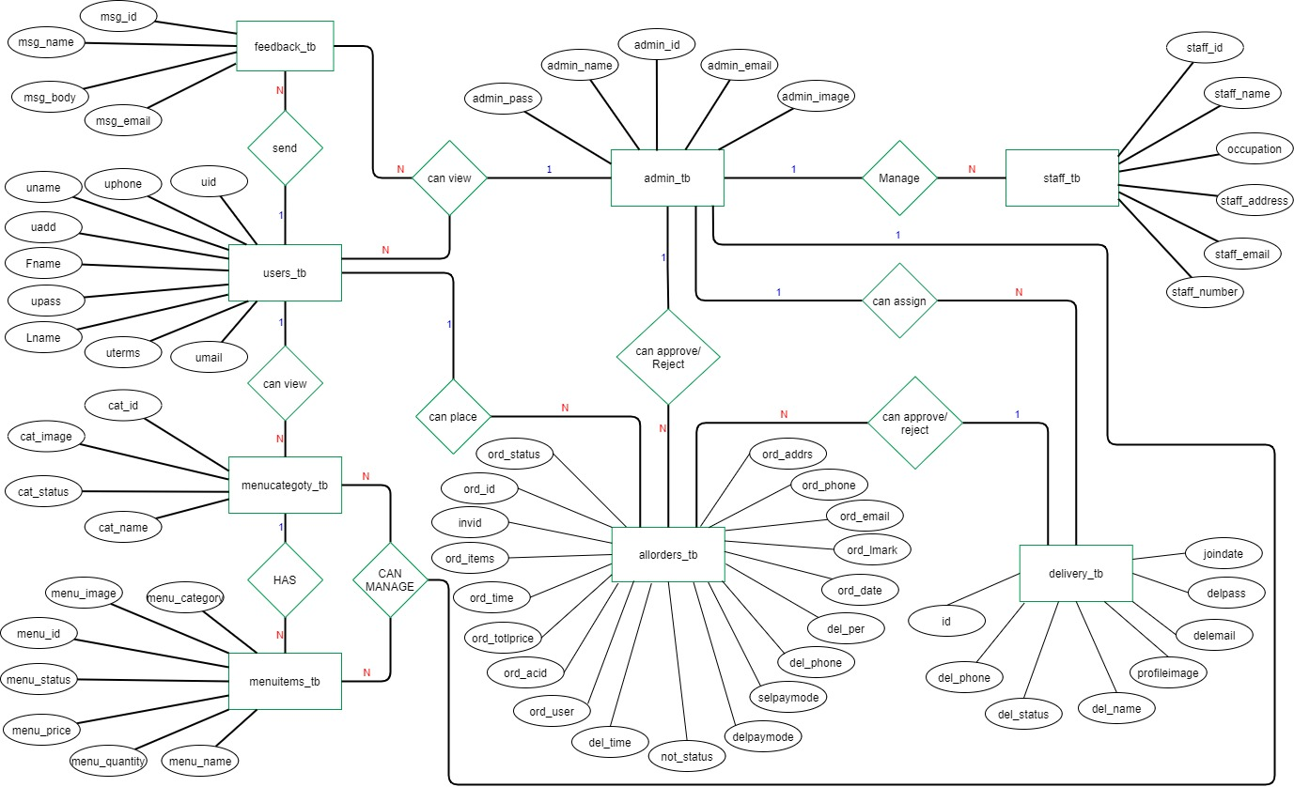

# Entity Relationship Diagram (ERD)

# Data Flow Diagram(DFD)

**Level 0 DFD**

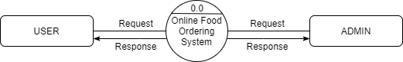

**Level 1 DFD (user)**

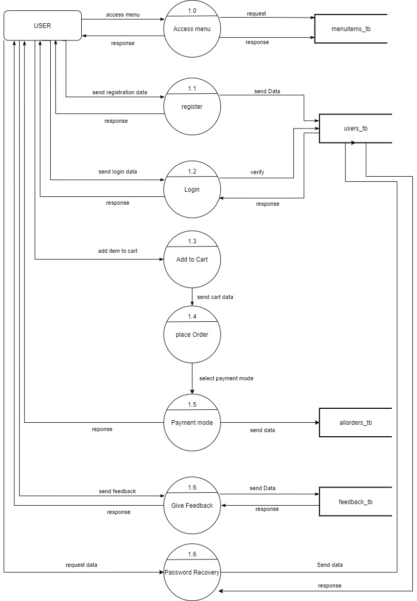

1.7

**Level 1 DFD (admin)**

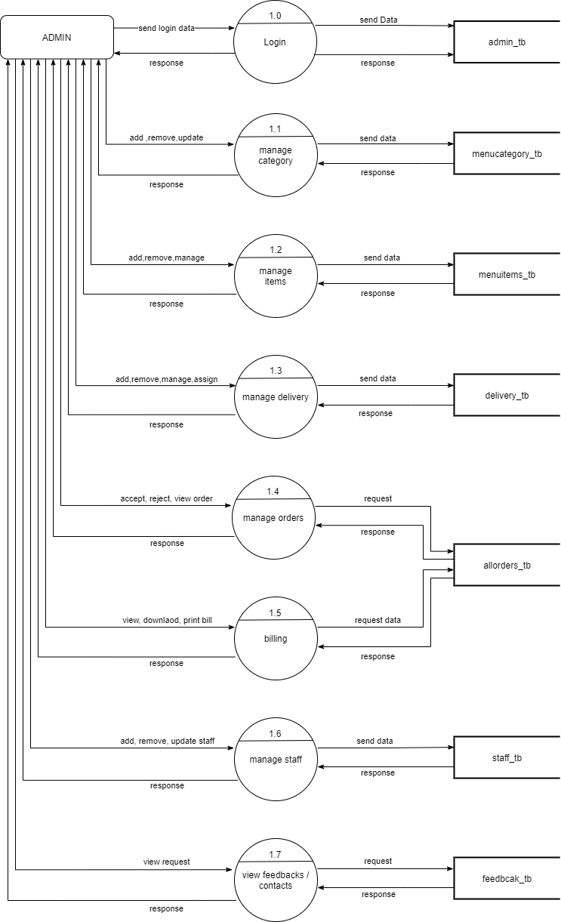

**Level 1 DFD (Delivery)**

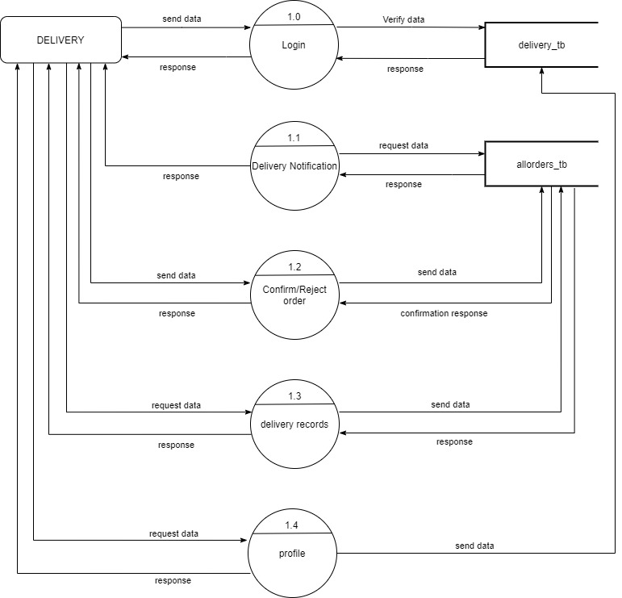

# Database

Database Name: **foodzilla**

**Table:**

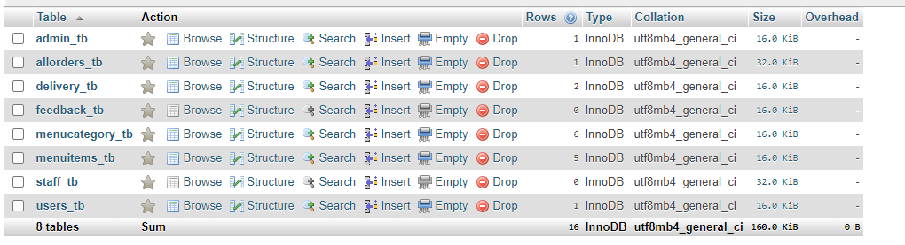

# Database Relational Table

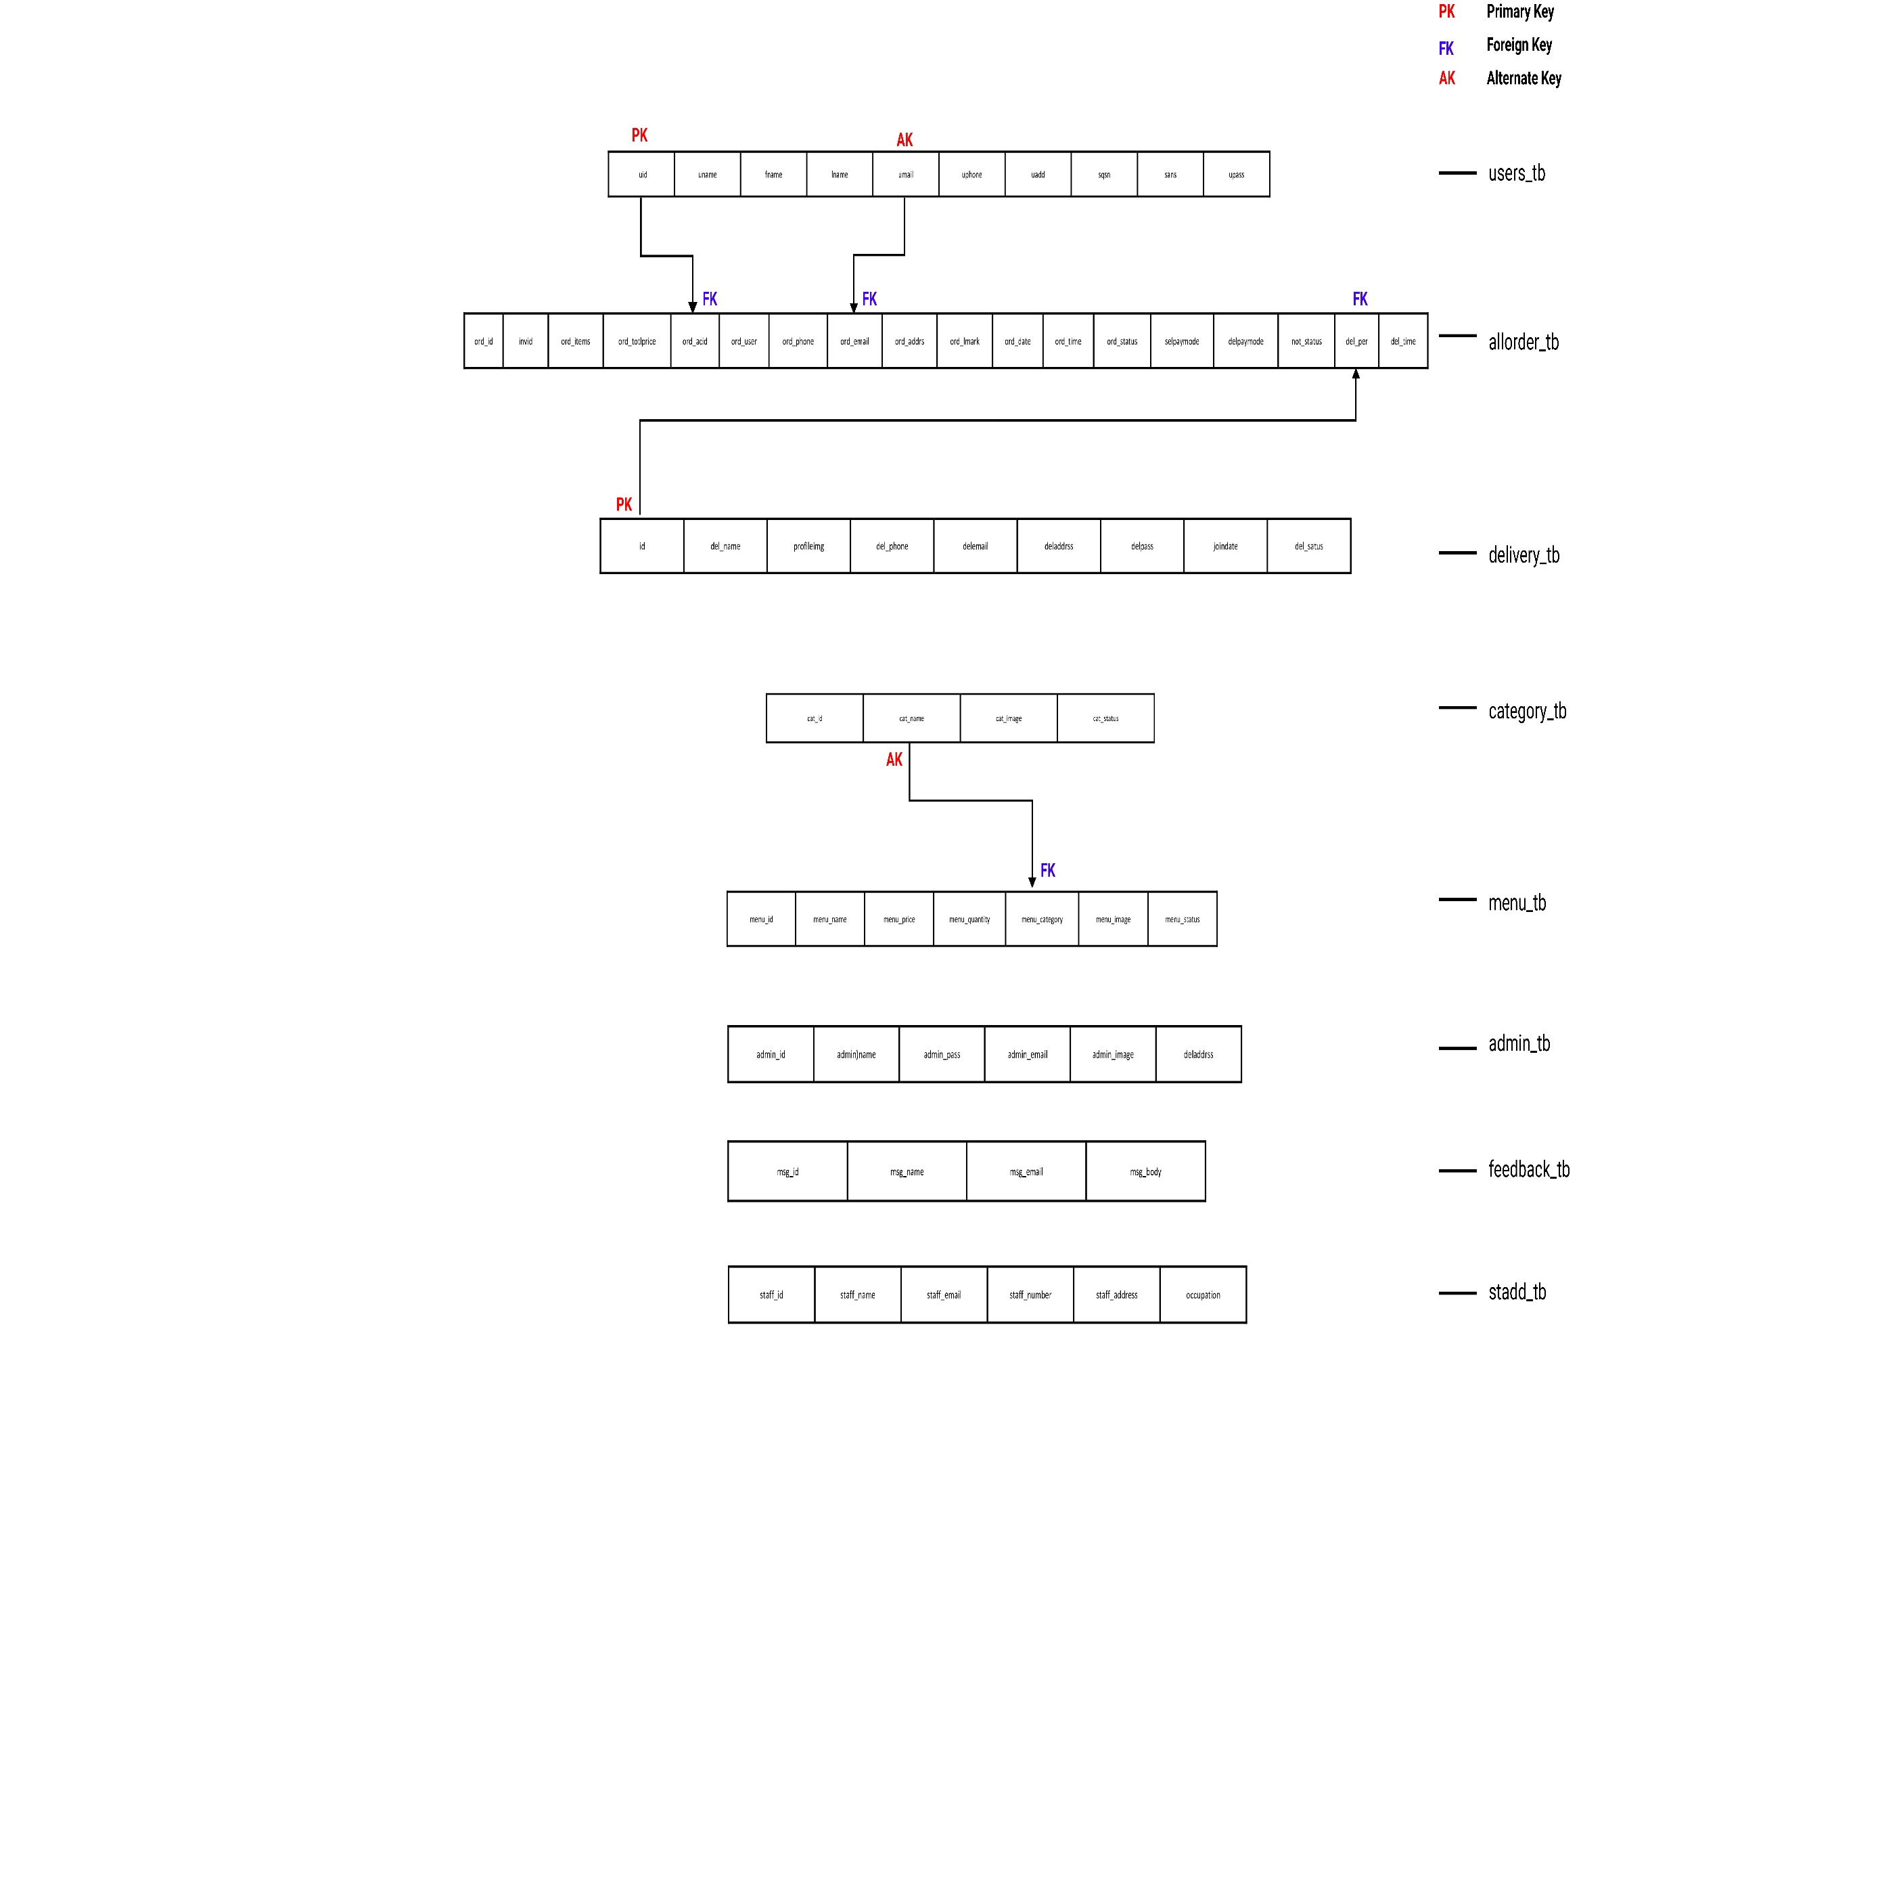

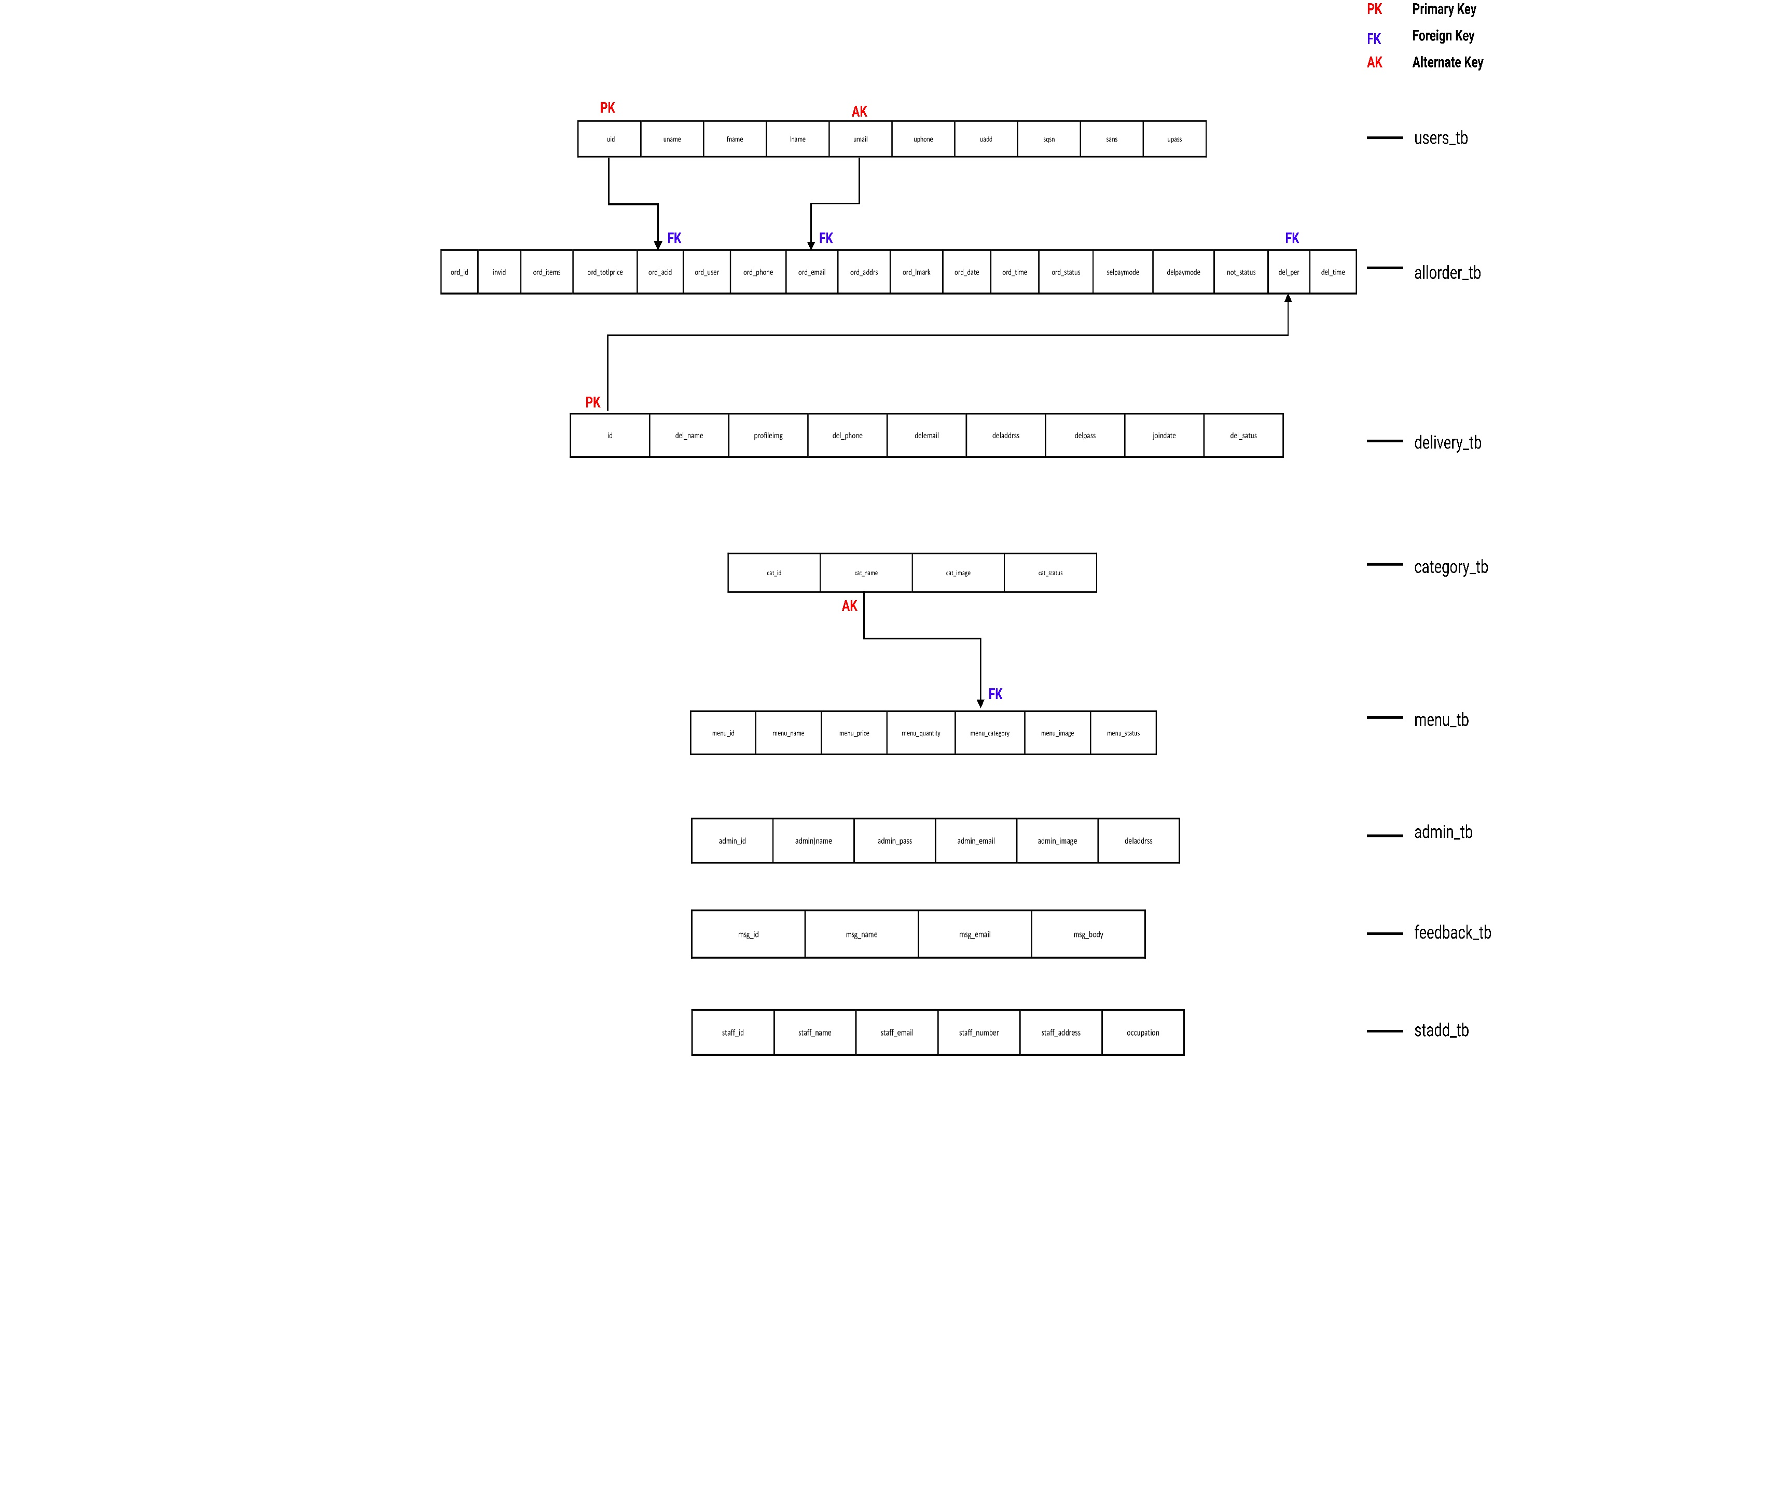

# Sitemap(Client)

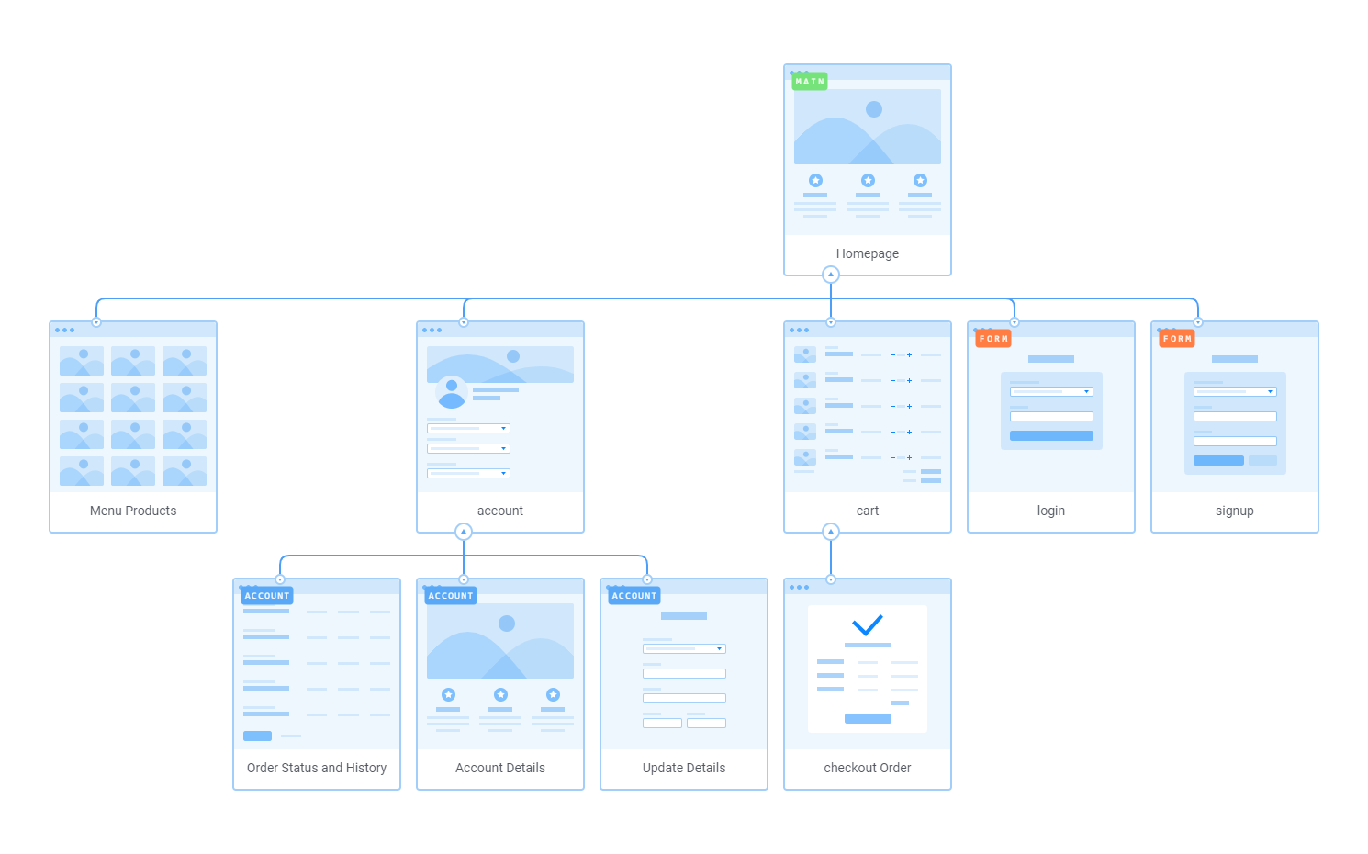

# Site map(Admin)

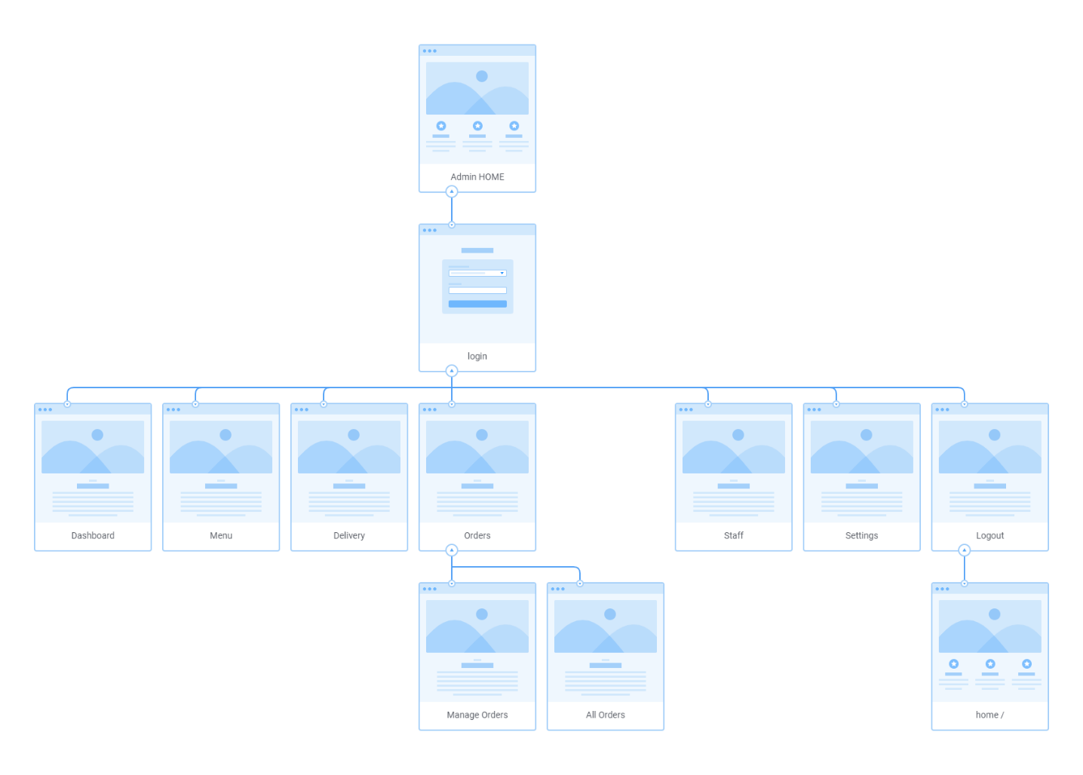

# Front End Snapshots(Client)

screenshots

* Home Page

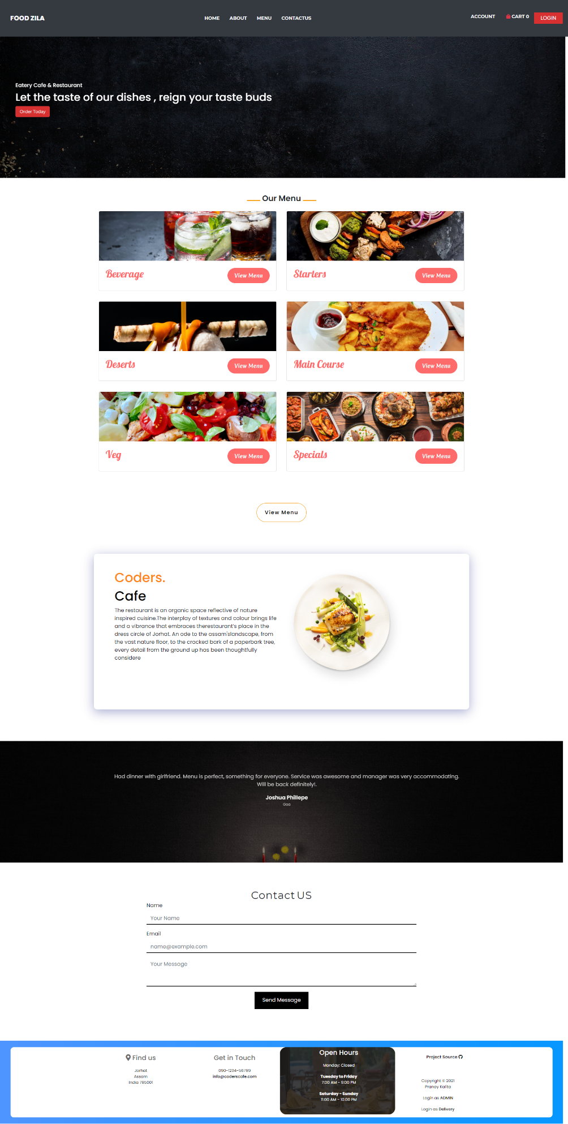

* Menu

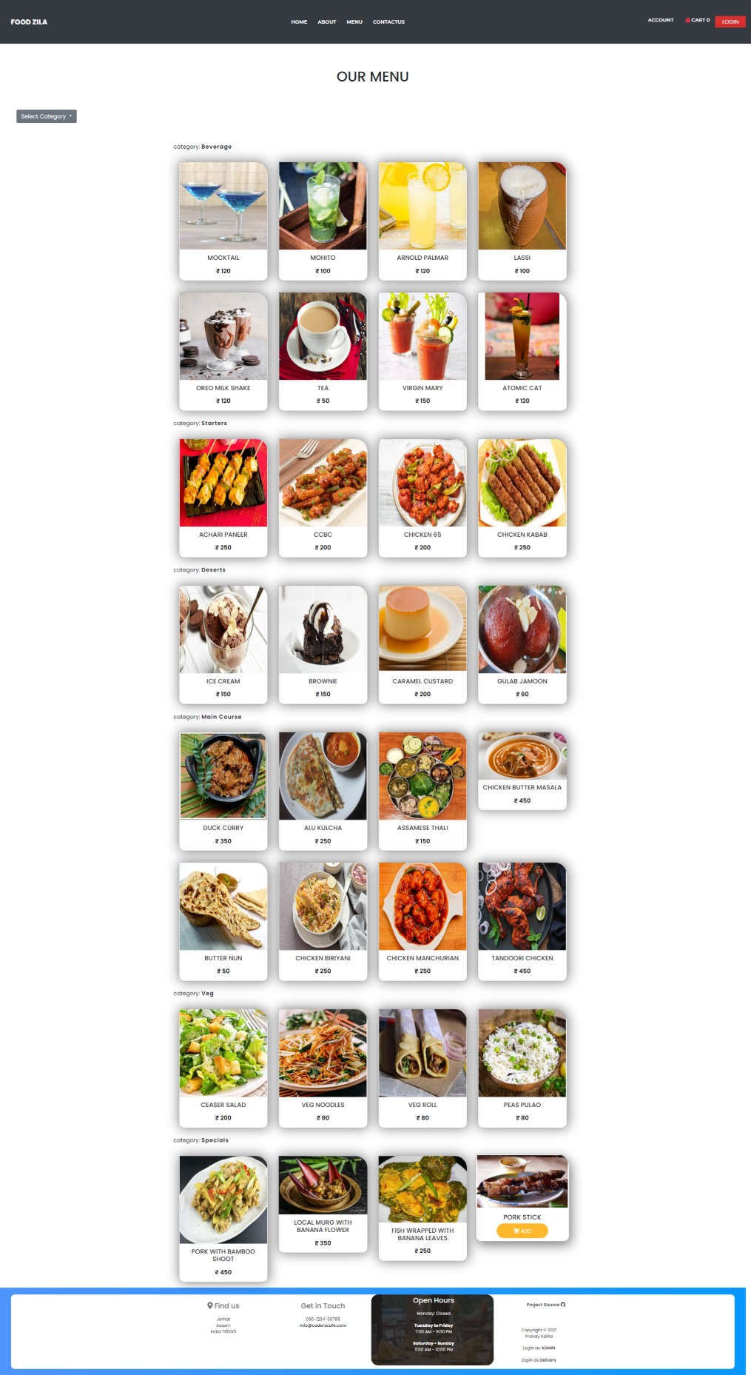

* Cart

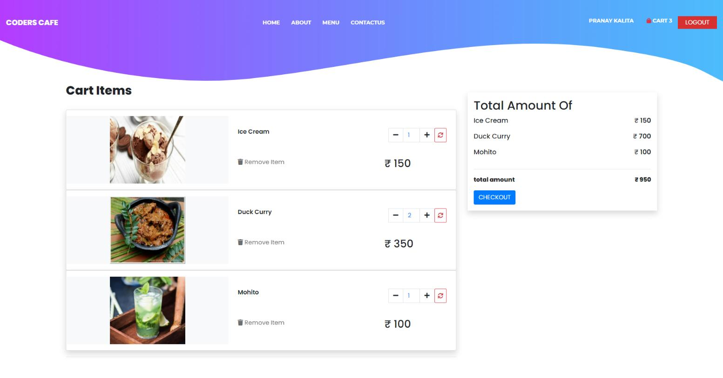

* Login

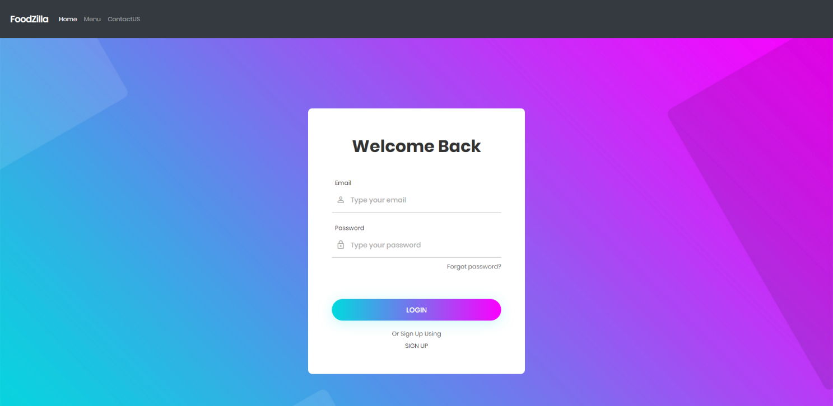

* Registration with checking already exist username and email

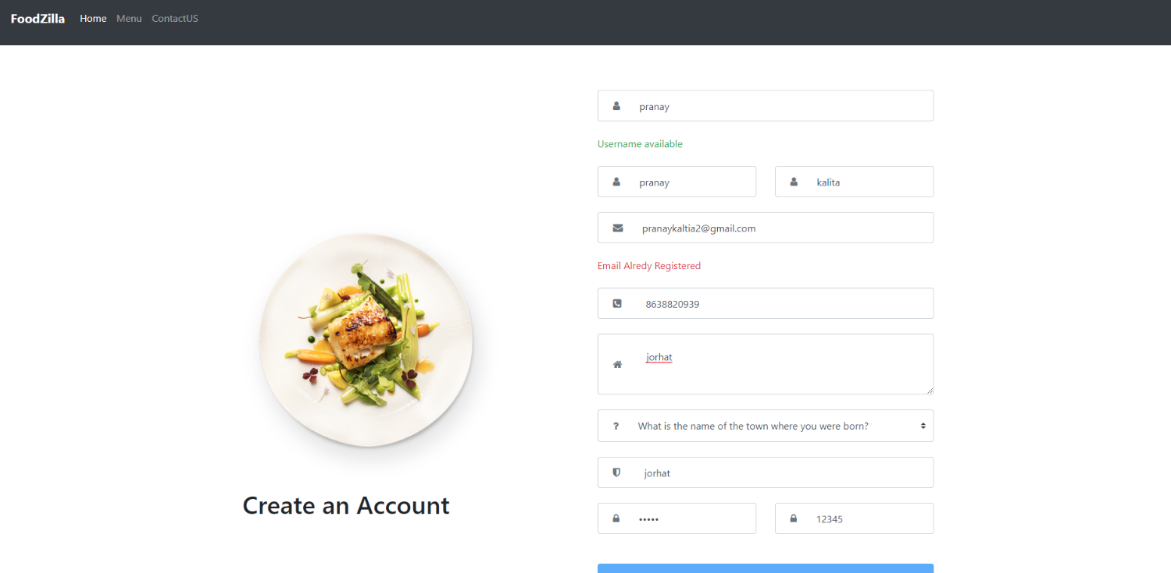

* Password Recovery

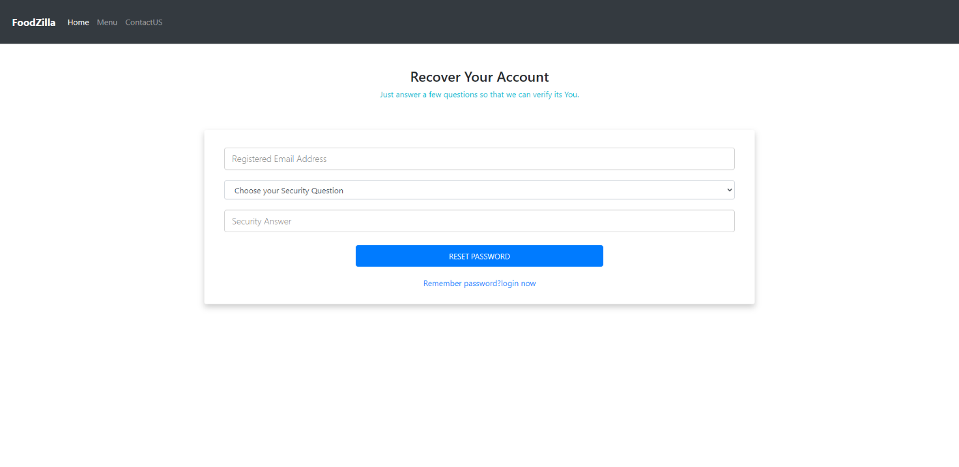

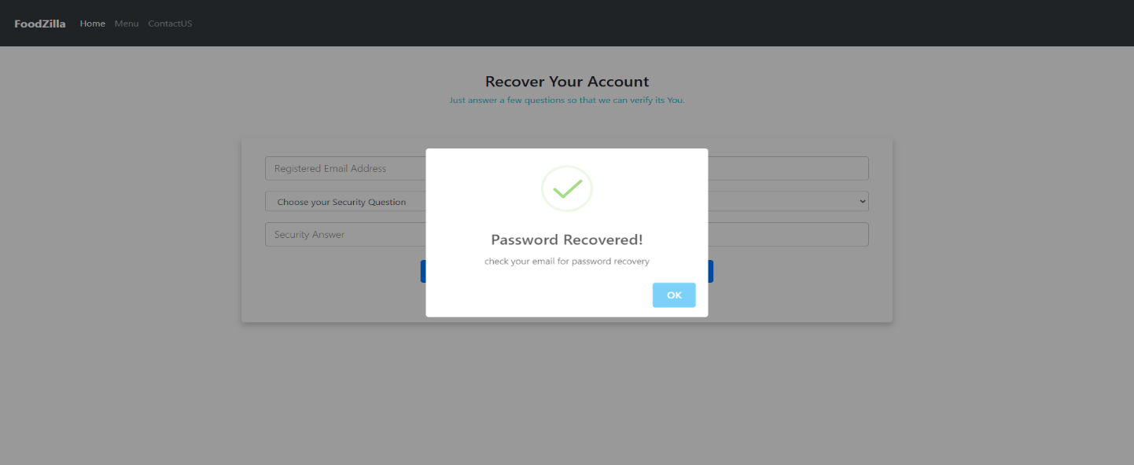

* Account Management

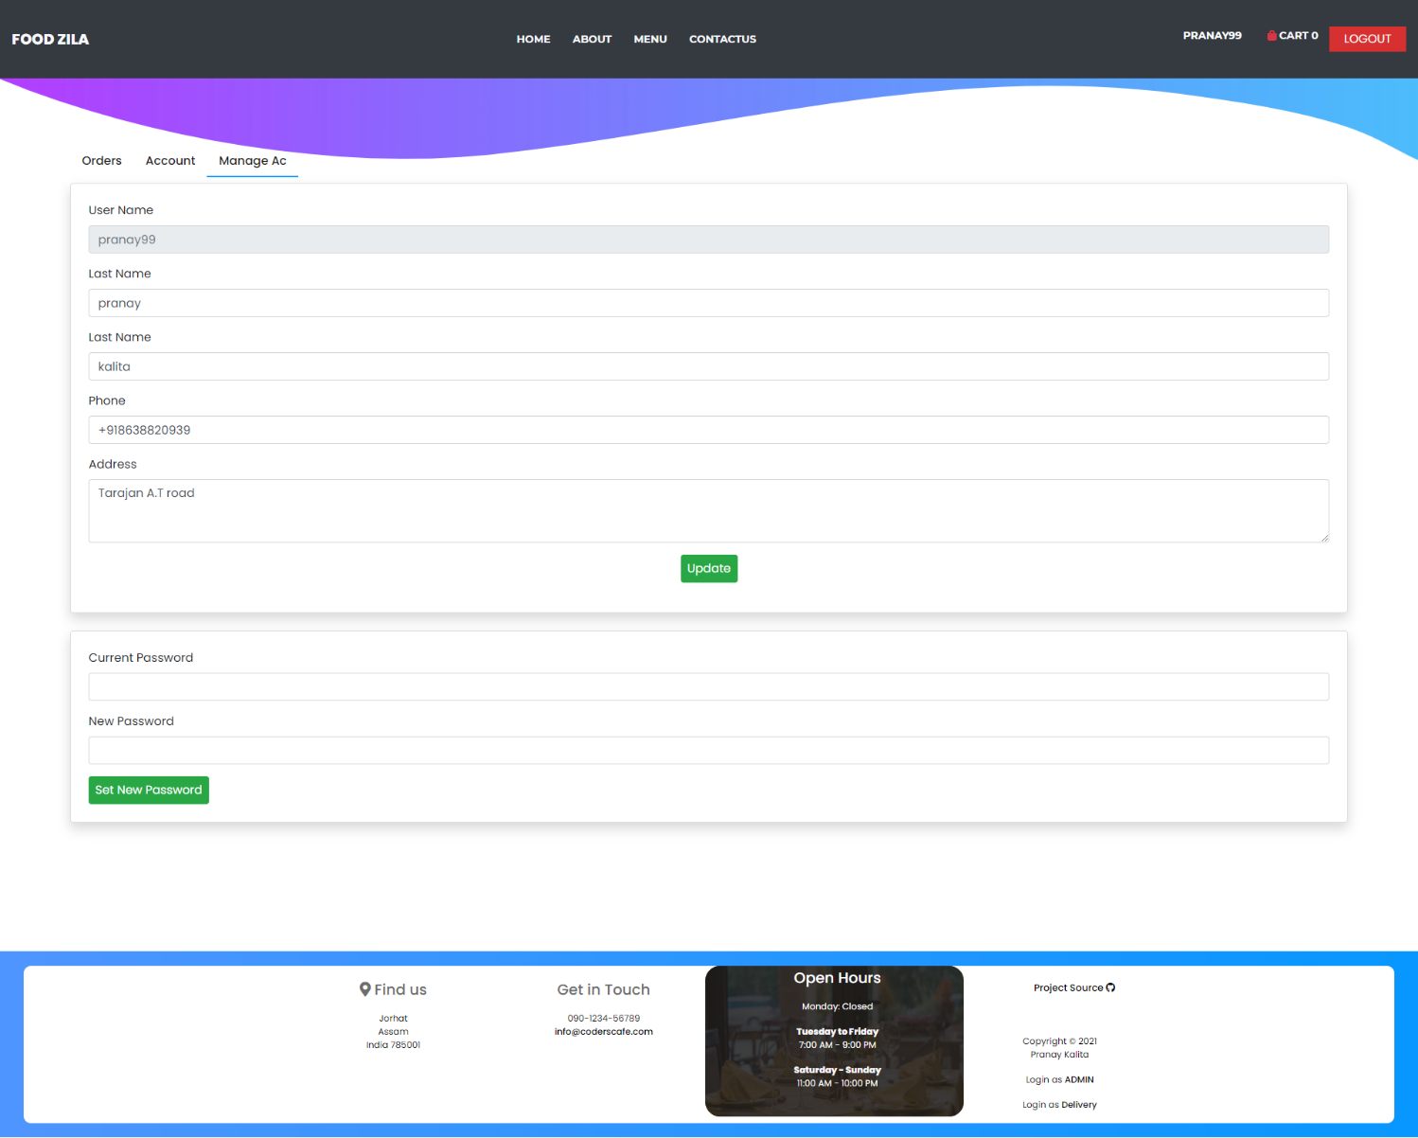

* Orders

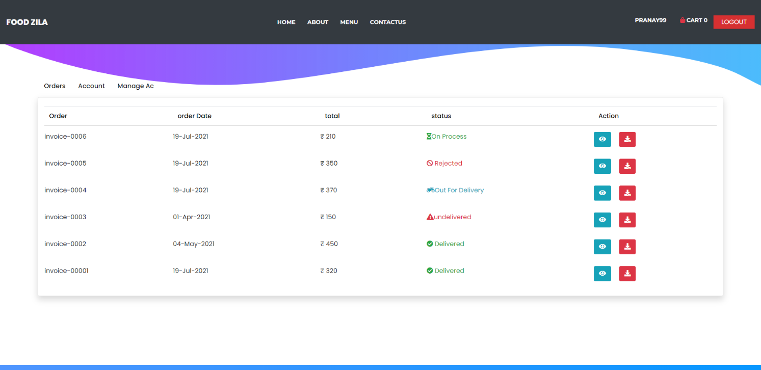

* Payment/checkout

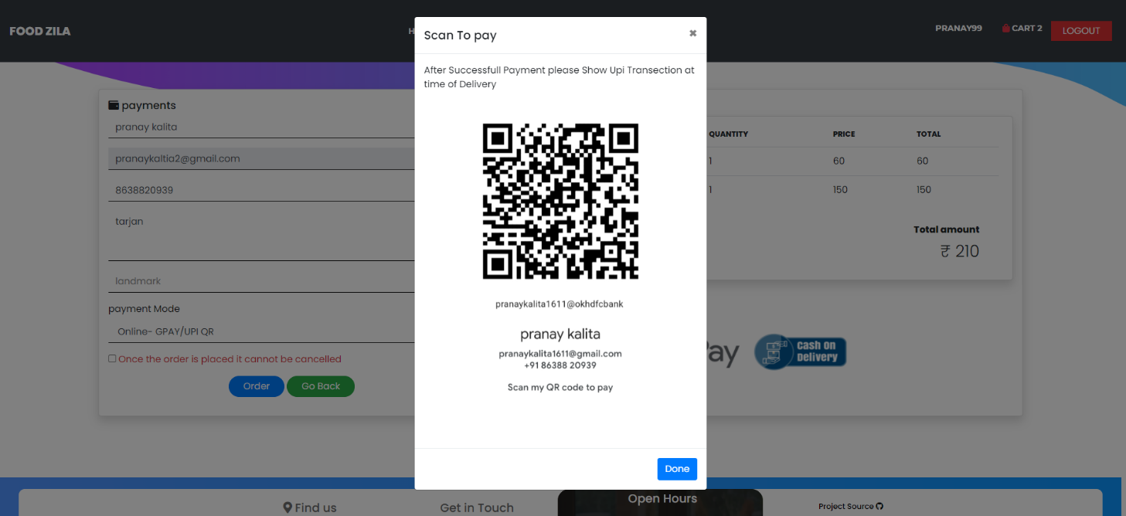

* Password recovery in email

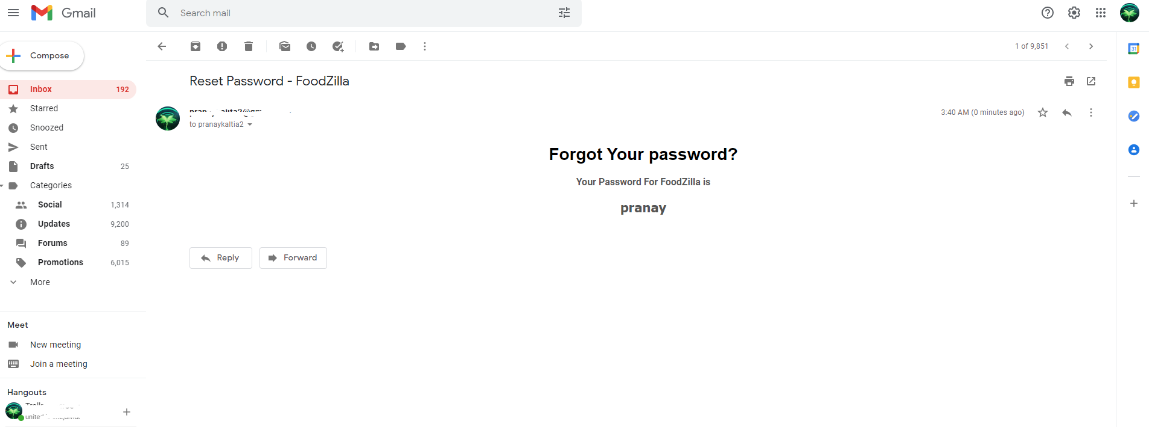

# Front End Snapshots(Admin)

screenshots

* Login

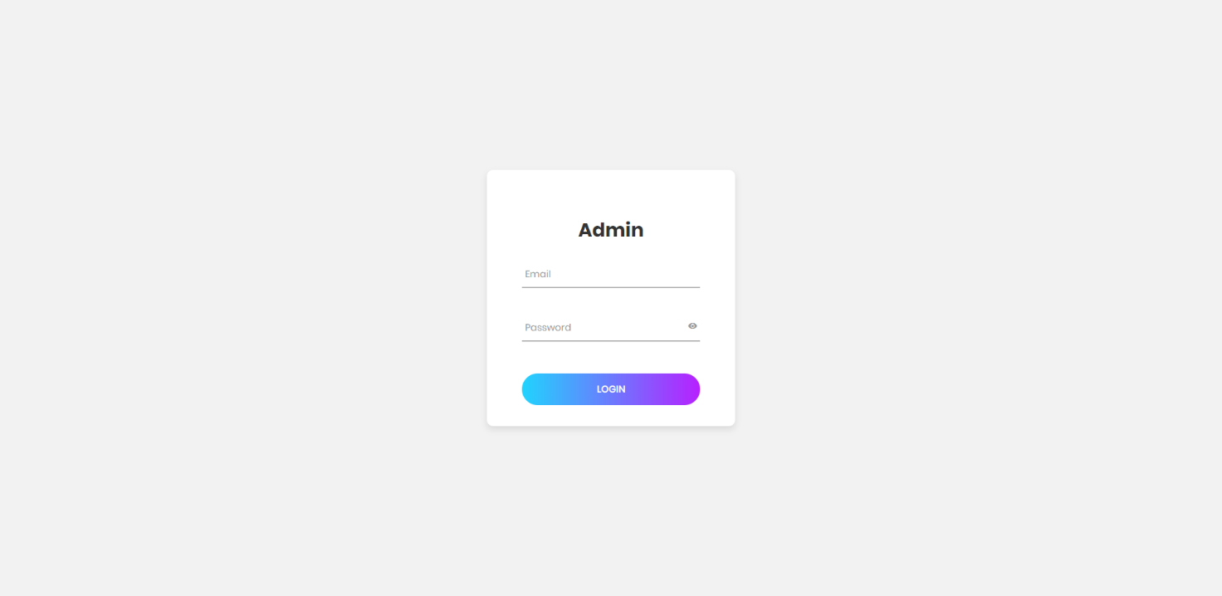

* Dashboard

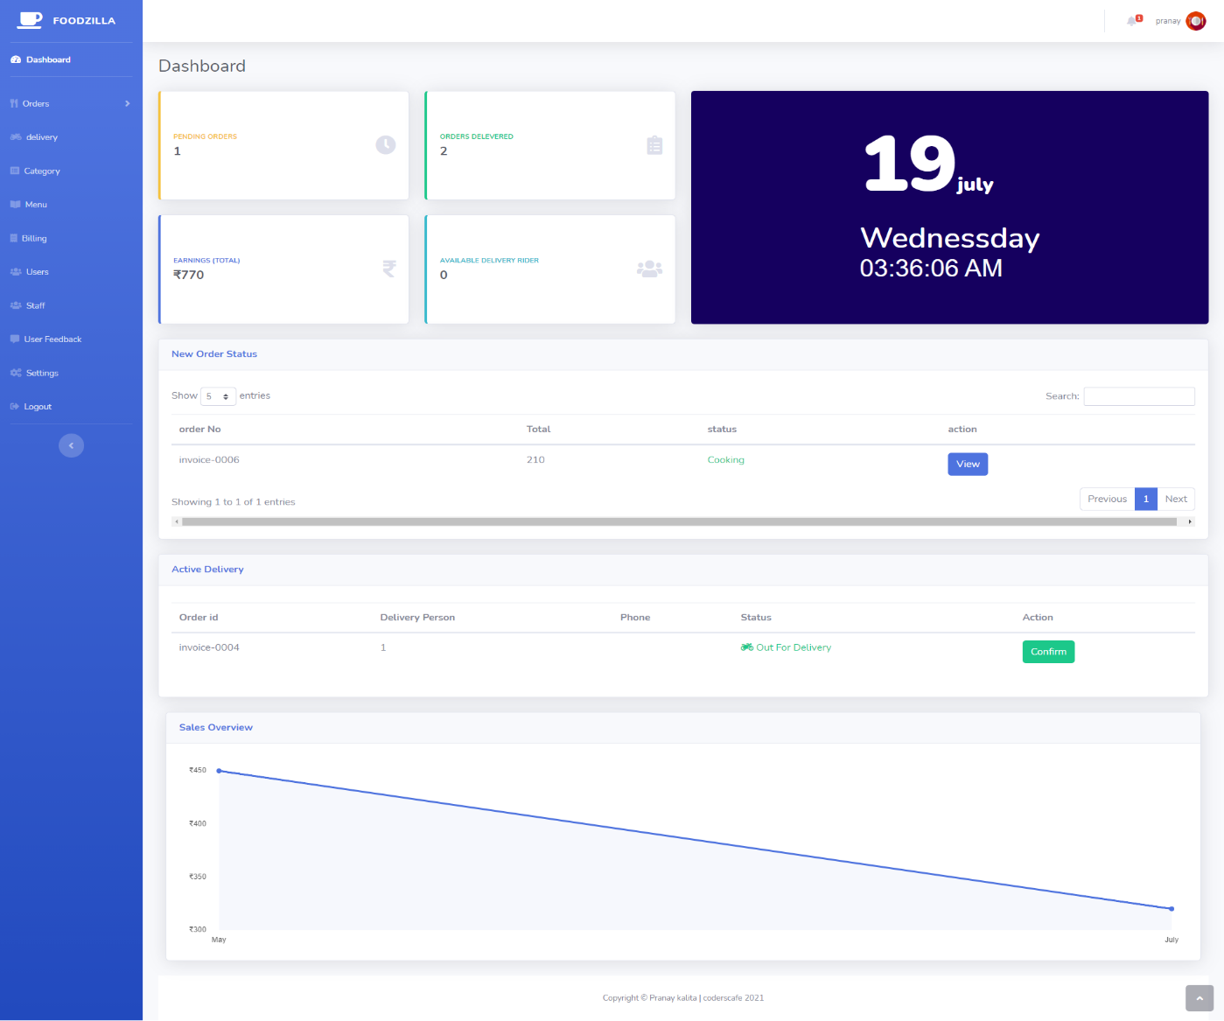

* New Order Notification

 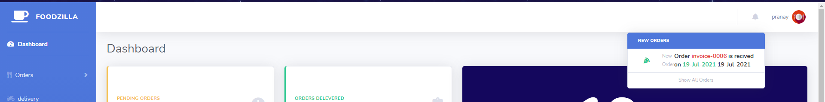

* New Orders

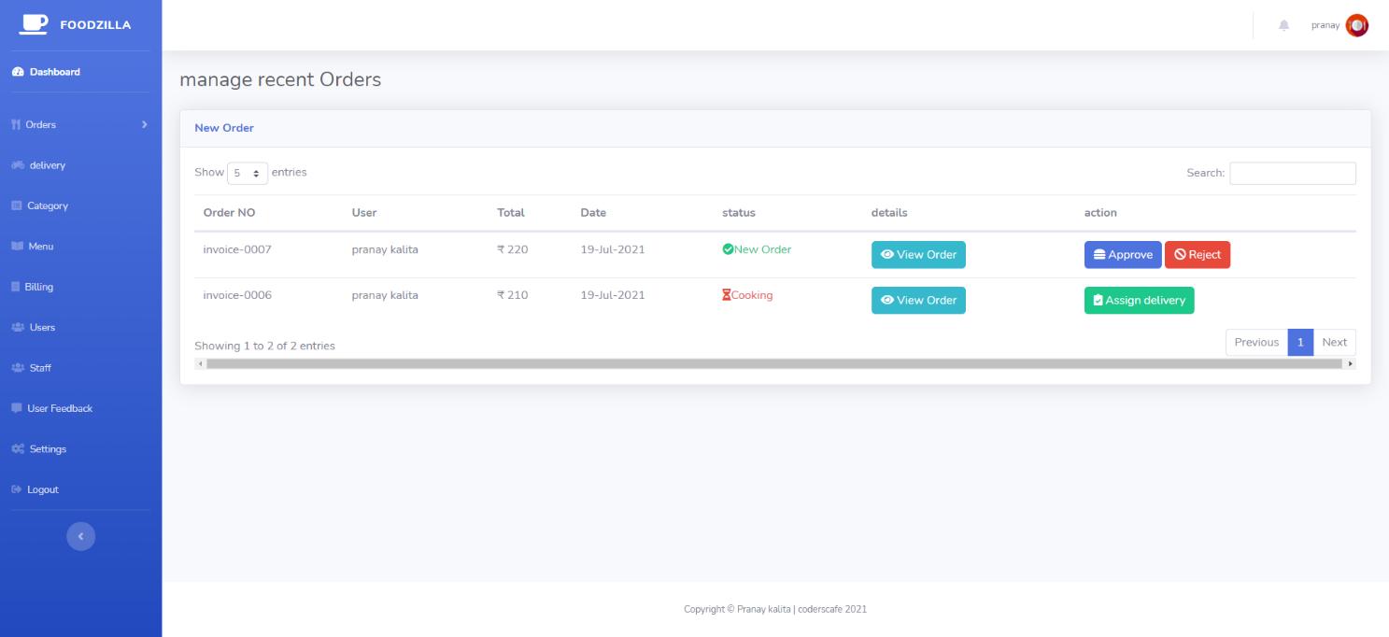

* All Orders

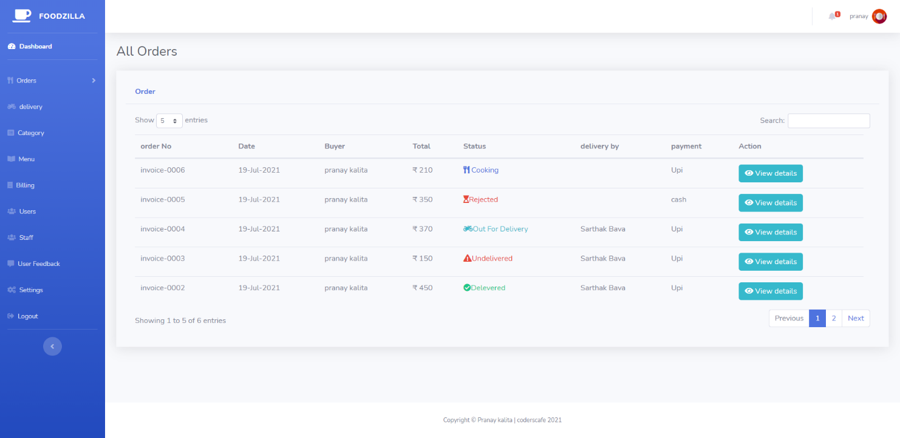

* Category Management

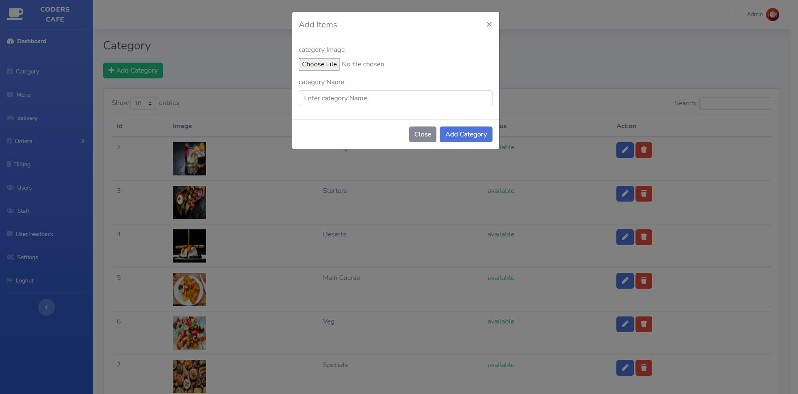

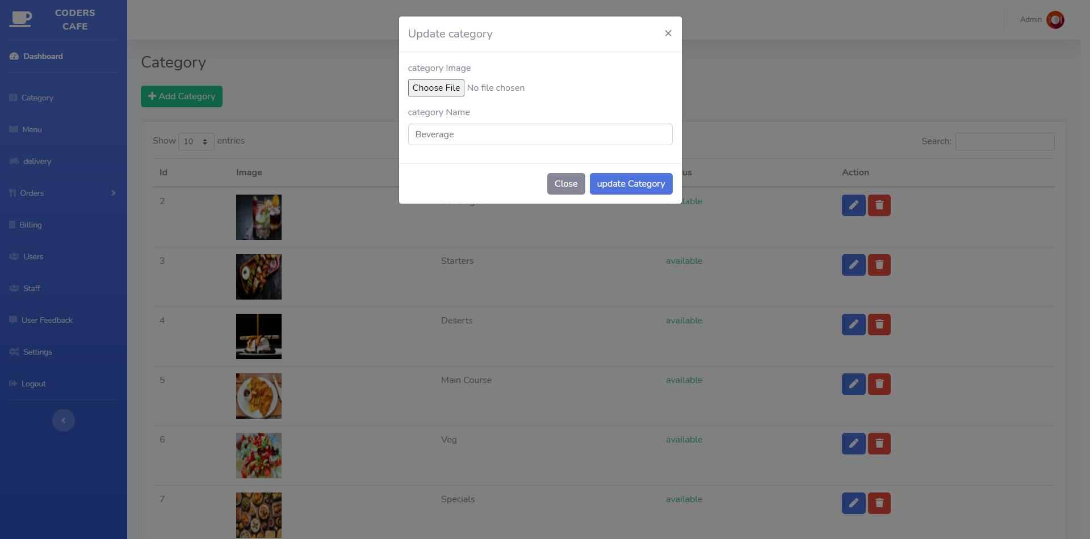

* Menu Management

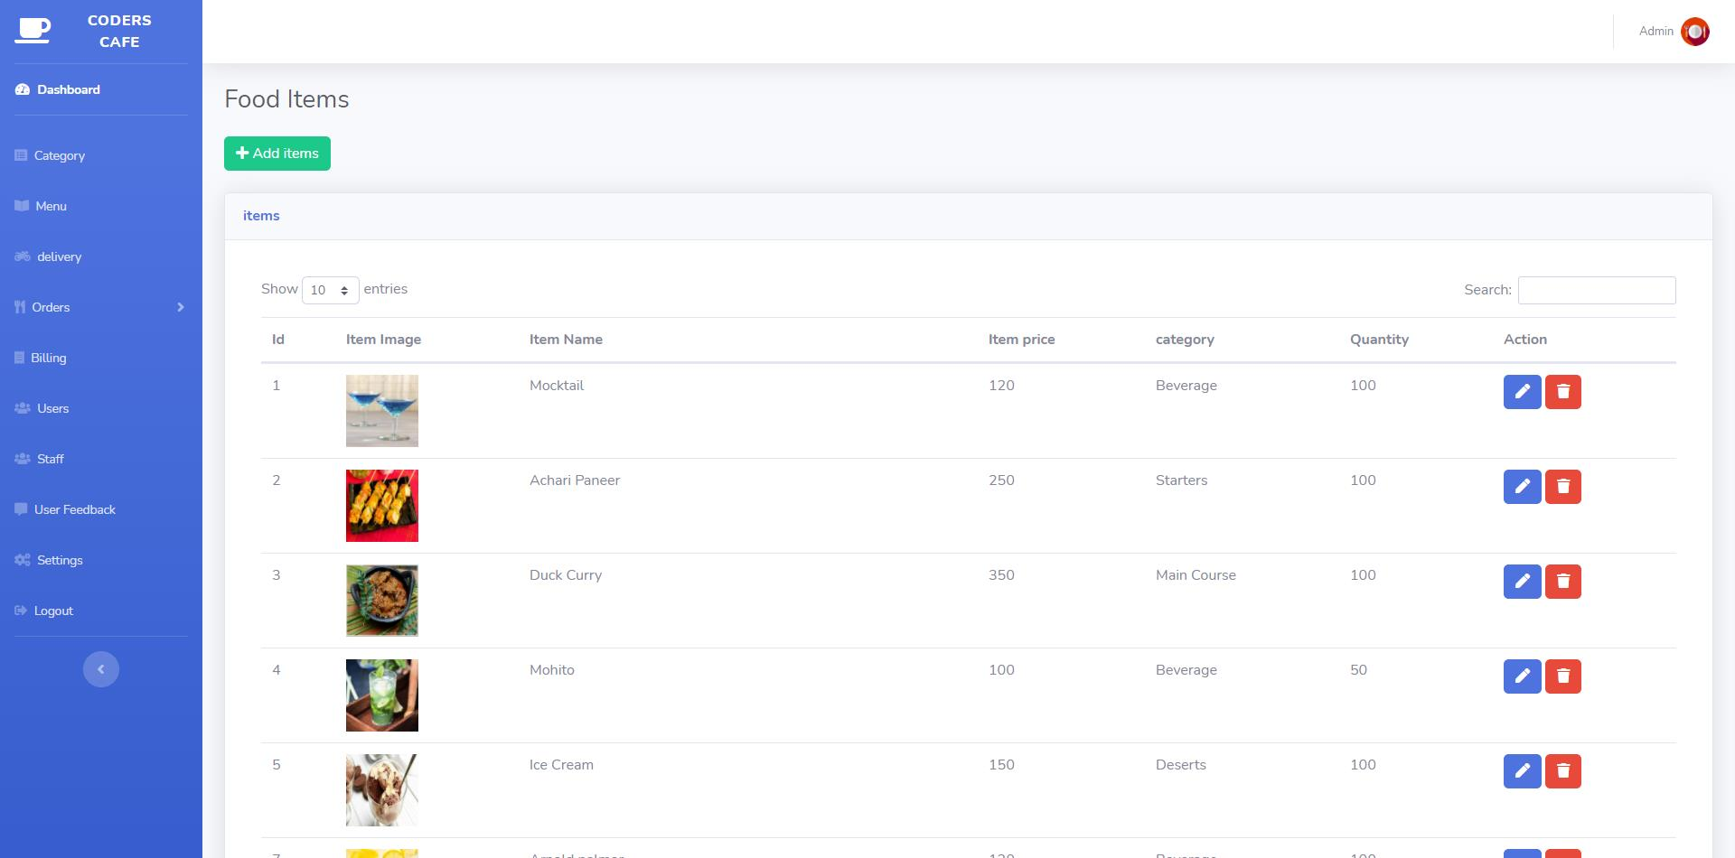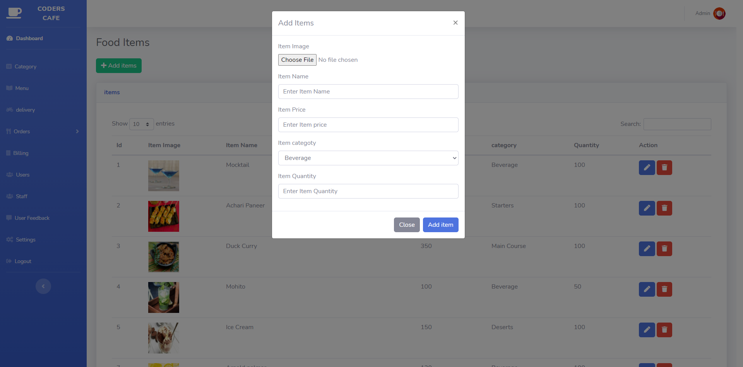

* Billing and customer Bills

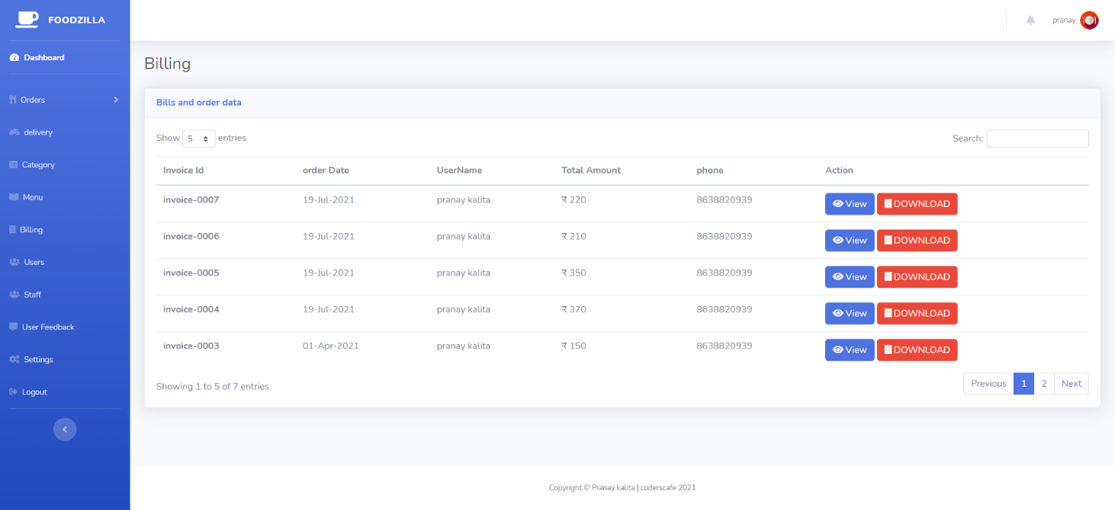

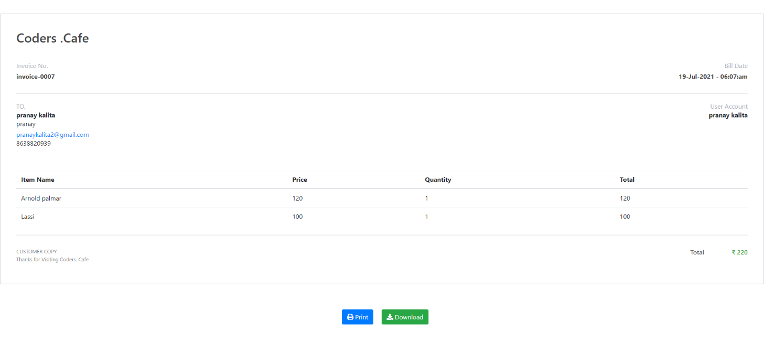

* Registered Users

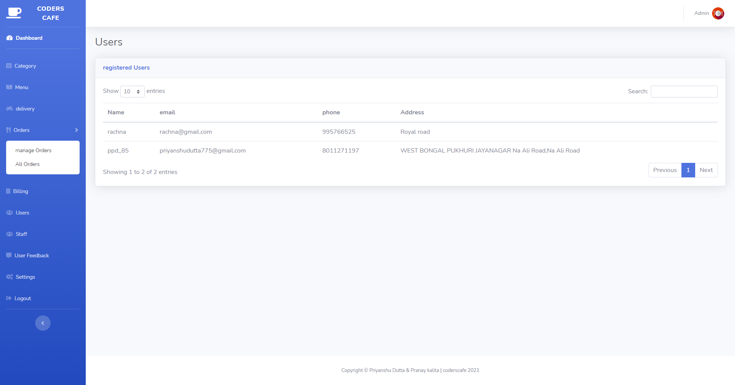

* Staff

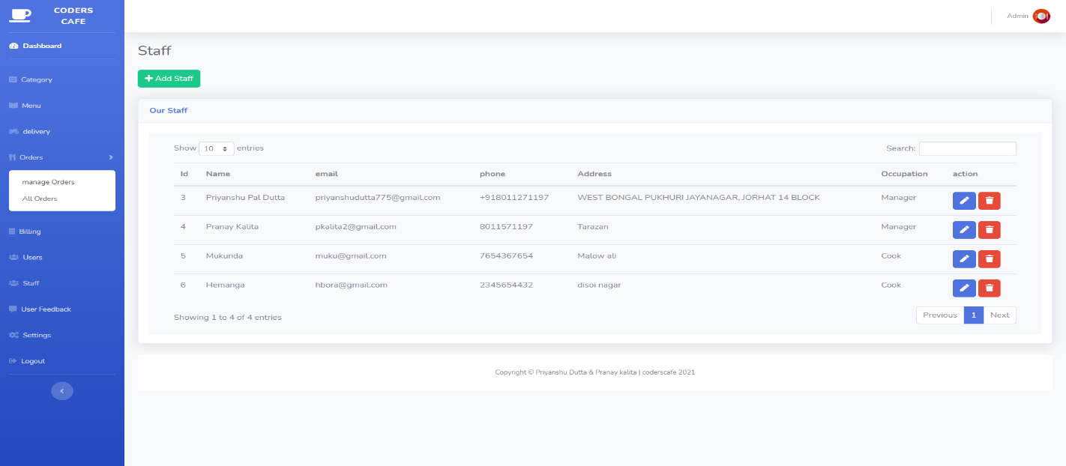

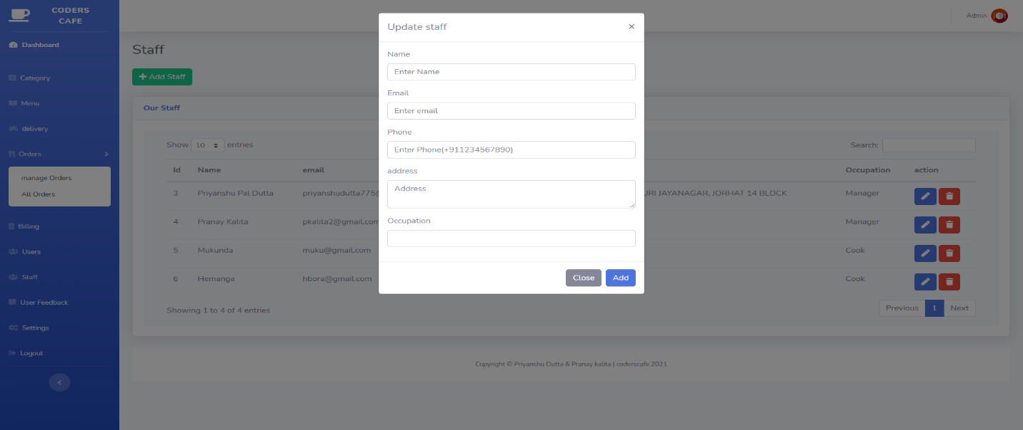

* Users Contact/Feedback

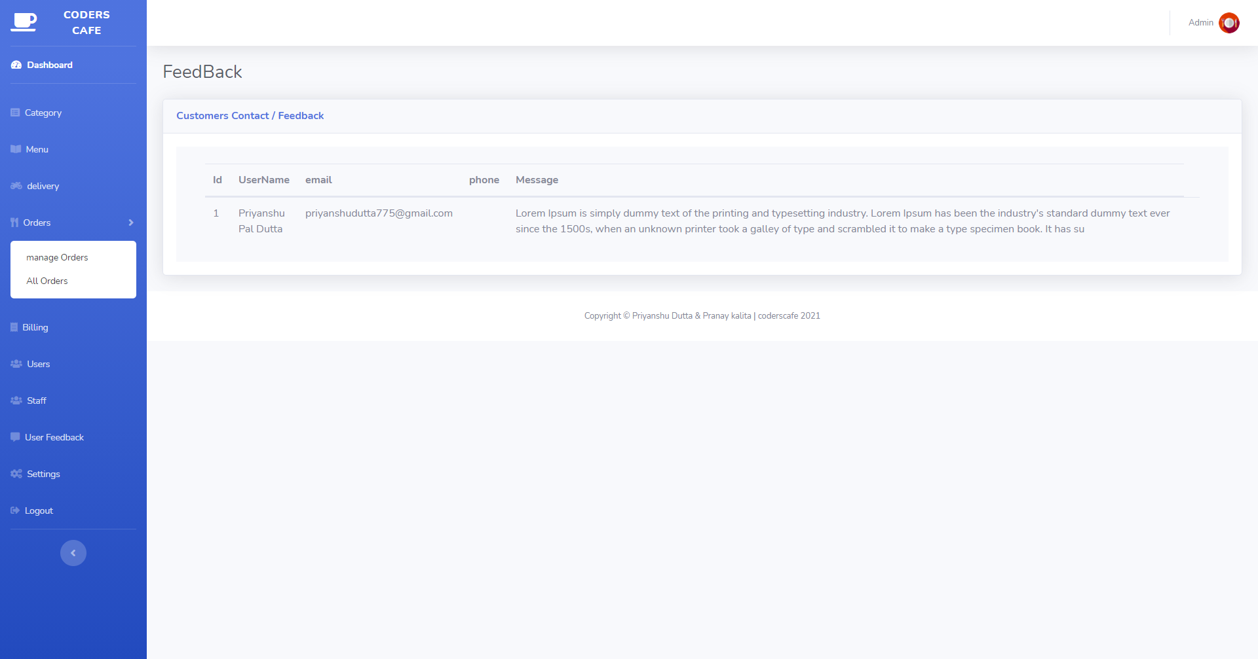

* Settings to Add new admin/reset Password

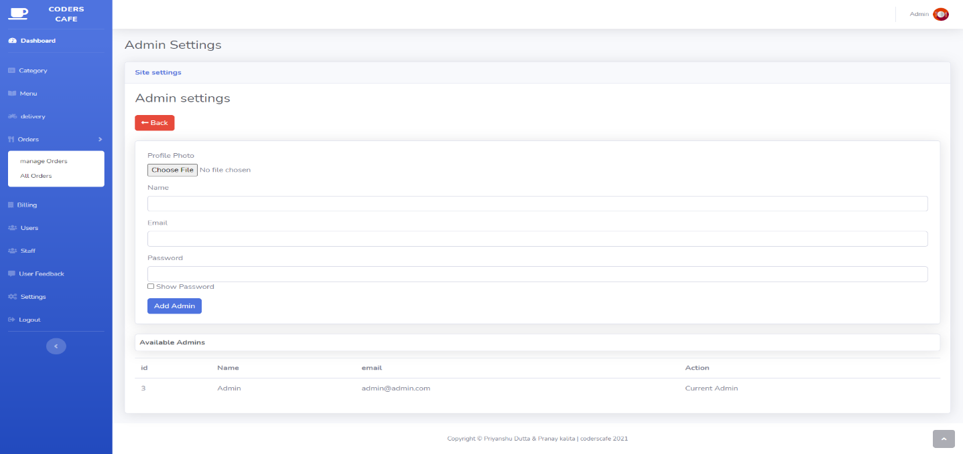

# Front End Snapshots(Delivery)

screenshots

* Dashboard

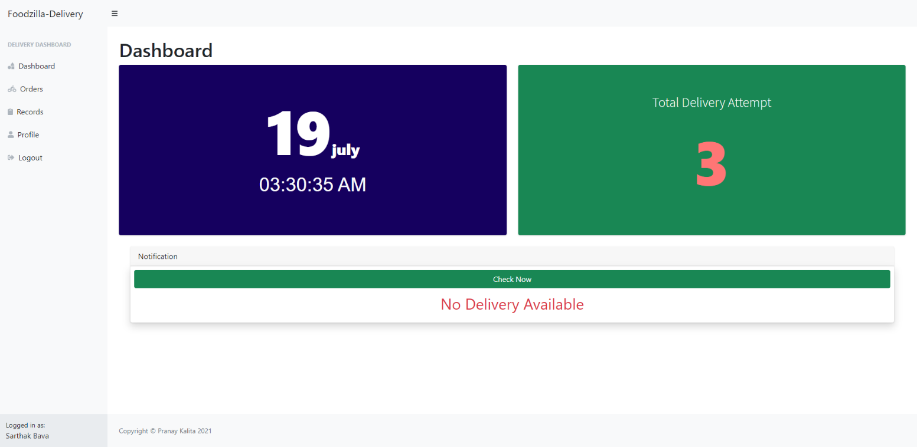

* Delivery Confirmation and choosing of payment modes

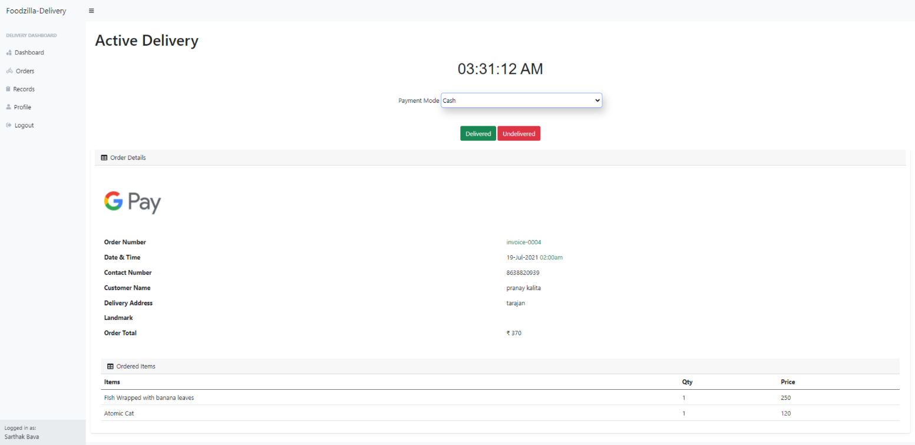

* All delivery records

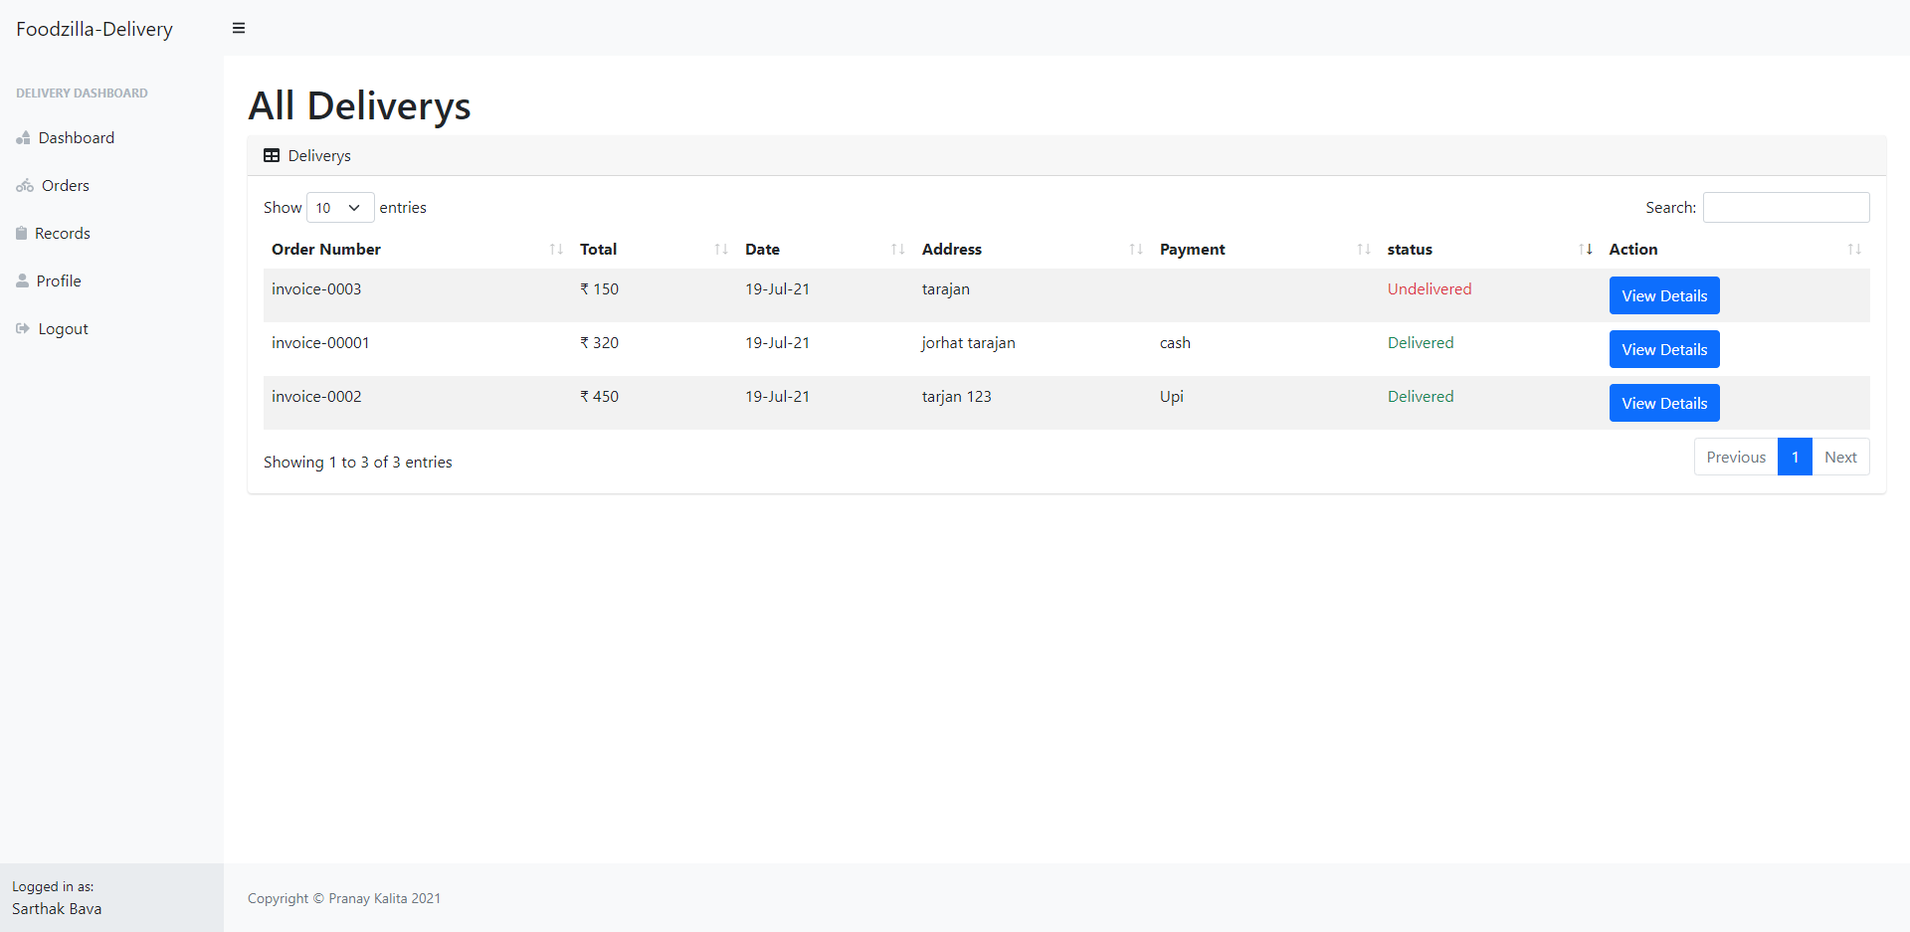

* Profile

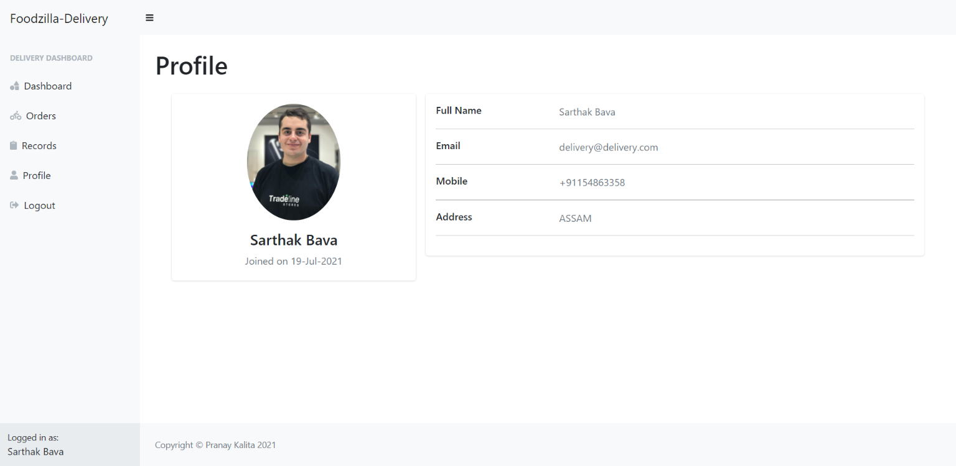

# Plugins

**Sweet Alert**

Sweet Alert is a way to customize alerts in your games and websites. It allows you to change from a standard JavaScript button

CDN

|  |
| --- |
| JS <script src="https://unpkg.com/sweetalert/dist/sweetalert.min.js"></script> |

To Call Sweet alert

|  |
| --- |
| 1 swal({  2 title: "Good job!",  3 text: "You clicked the button!",  4 icon: "success",  5 }); |



**DataTables**

DataTables is a plug-in for the jQuery JavaScript library. It is a highly flexible tool, built upon the foundations of progressive enhancement, that adds all of these advanced features to any HTML table.

To implement DataTables

1. Include these two files

|  |
| --- |
| CSS //cdn.datatables.net/1.10.23/css/jquery.dataTables.min.css |
| JS //cdn.datatables.net/1.10.23/js/jquery.dataTables.min.js |

2. Call this Single function to activate

|  |
| --- |
| 1 $(document).ready( function () {  2 $('#myTable').DataTable();  3 } ); |

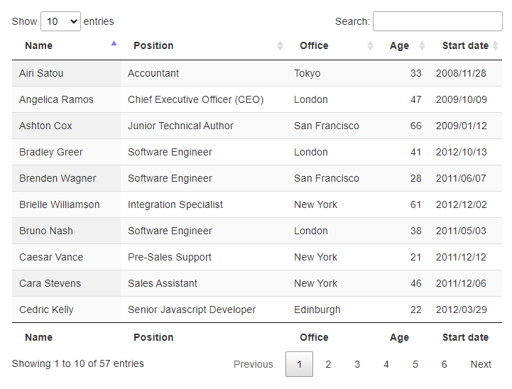

**Owl Carousel**

Owl carousel is a touch enabled jQuery plugin that lets you create beautiful responsive carousel sliders.

CDN

|  |
| --- |
| CSS <link rel="stylesheet" href="owlcarousel/owl.carousel.min.css">  <link rel="stylesheet" href="owlcarousel/owl.theme.default.min.css">  JS <script src="owlcarousel/owl.carousel.min.js"></script> |

Call Owl carousel

|  |
| --- |
| 1 $(document).ready(function(){  2 $(".owl-carousel").owlCarousel();  3 }); |

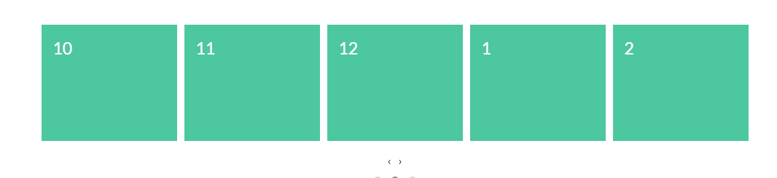

**Html2pdf**

html2pdf.js converts any webpage or element into a printable PDF entirely client-side using html2canvas and jsPDF.

CDN

|  |
| --- |
| JS raw.githack.com/eKoopmans/html2pdf/master/dist/html2pdf.bundle.js |

Usage

|  |
| --- |
| 1 var element = document.getElementById('element-to-print');  2 html2pdf(element); |

# Testing Technologies

**PURPOSE OF TESTING**

The purpose of testing is to ensure a quality product, which is reasonably bug free; it is a process which assures that the product is in synchronization with the requirements specified by the client and the client finally gets what he has asked for without any problems in the software.

**TESTING AND DETAILS**

* **UNIT TESTING**

Unit testing is a level of software testing where individual units/ components of a software are tested. The purpose is to validate that each unit of the software performs as designed. A unit is the smallest testable part of any software. In this level, we have tested all our unit/components individually. This testing includes testing of control paths, interfaces, local data structures, logical decisions, boundary conditions, and error handling. From this testing we were able to save, retrieve, update, delete and the search records on a table.

* **INTEGRATION TESTING**

Integration testing is used to verify the combination of the software modules. In this level, we have tested by combining all unit tested forms into a subsystem. Here we found that the subsystems are performing well.

* **SYSTEM TESTING**

System testing is used to verify, whether the developed system meets the requirements. Here we have found that the developed system met its requirement.

* **ACCEPTANCE TESTING**

Acceptance is the part of the project by which the user accepts the product. The system under consideration is tested for user acceptance by constantly keeping in touch with the system users at time of developing and making changes whenever required.

We hope that after the acceptance testing the system will perform the best result for the university. When modification will be made, we will use regression testing during the maintenance of the system. The Application delivered to the user may undergo changes. Changes may be due to addition of new functional modules or performance enhancement. For this purpose, proper maintenance of the system is must.

# Conclusion

The package was designed in such a way that future modifications can be done easily. The following conclusions can be deduced from the development of the project.

* Automation of the entire system improves the efficiency
* It provides a friendly graphical user interface which proves to be better when compared to the existing system.
* It gives appropriate access to the authorized users depending on their permissions.
* It effectively overcomes the delay in communications.
* Updating of information becomes so easier.
* System security, data security and reliability are the striking features.
* The System has adequate scope for modification in future if it is necessary.

# Bibliography & Reference

1. <http://www.tutorialspoint.com>
2. <https://www.w3schools.com/>
3. <https://www.youtube.com/>
4. <https://getbootstrap.com/>